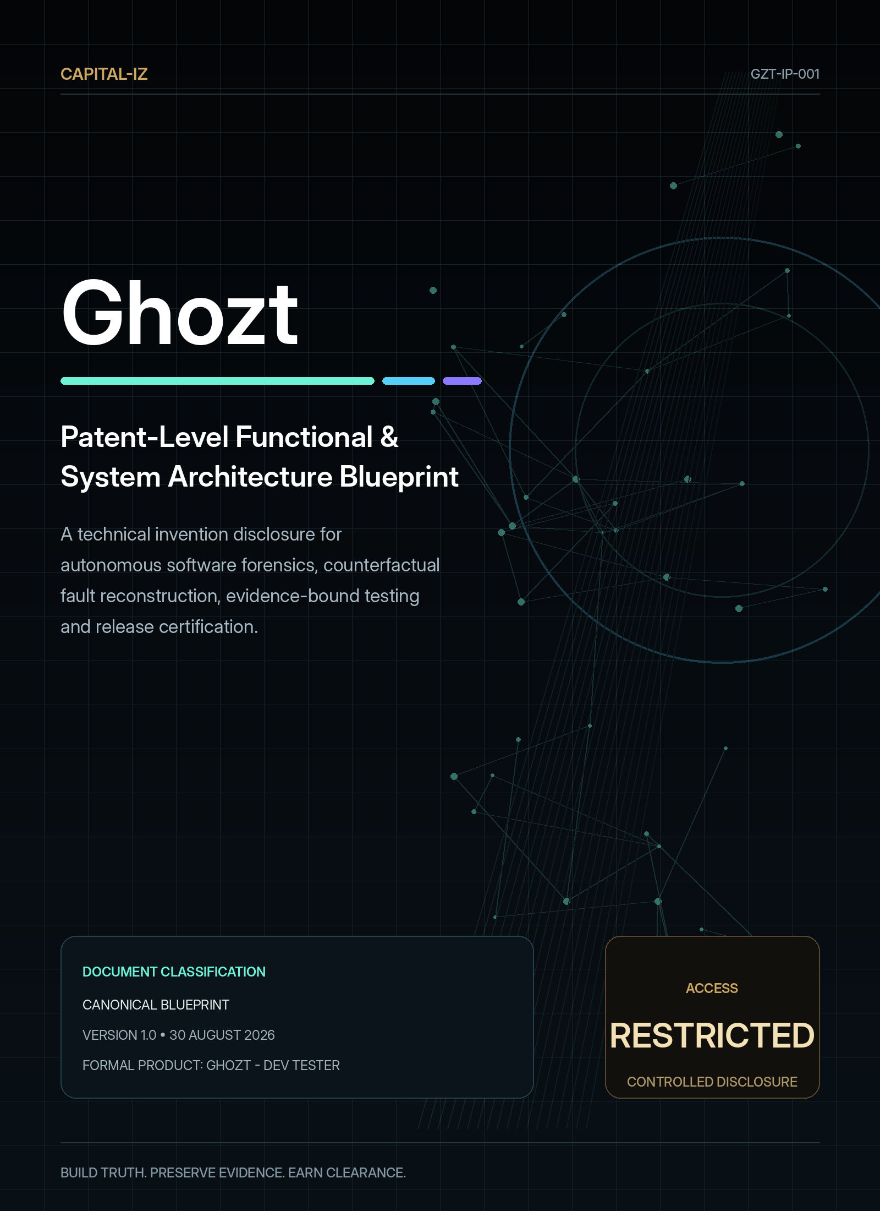

DOCUMENT CONTROL

Ghozt Patent-Level Functional & System Architecture Blueprint
Provides an engineering-grade invention disclosure and full feature architecture for autonomous software forensics, exhaustive state exploration, counterfactual fault reconstruction, evidence-bound repair and quality certification.
Document code | GZT-IP-001
Product | Ghozt - Dev Tester
Visible brand | Ghozt
Portfolio identity | Capital-Iz Ghozt
Version | 1.0
Issue date | 30 August 2026
Status | Controlled technical invention disclosure
Scope | Technical architecture, methods, data structures, algorithms, agent governance, validation coverage, reporting, release clearance and candidate inventive concept families.
Authority | Capital-Iz product and engineering governance
Source inheritance | Capital-Iz Dev Tester Platform Blueprint; Universal Blueprint Development Doctrine; AI Architecture Blueprint; Universal Design System; CommandDeck implementation reference

CONTROLLED INTERPRETATION
This blueprint defines intended product behaviour and design authority. It does not authorise unbounded access to third-party systems. Ghozt must operate only against targets, environments and actions for which the operator has explicit permission.

LEGAL STATUS
This document is an engineering and product invention disclosure, not a filed patent, patentability opinion, freedom-to-operate opinion or substitute for patent counsel. Any public filing requires a formal prior-art search, jurisdiction-specific drafting and legal review.

01 • INVENTION SUMMARY

Abstract
Ghozt is a computer-implemented system for converting intended software behaviour into an evidence-bound behavioural model, autonomously exploring reachable application and system states, detecting differences between expected and actual outcomes, reconstructing the event sequence that produced a deviation, testing counterfactual conditions to support or reject causal hypotheses, generating bounded repair guidance, verifying repairs through reproduced and adjacent paths, preserving chain-of-custody evidence and computing policy-based release clearance.
The system may receive product ideas, specifications, designs, source code, existing tests, API contracts, deployed applications, algorithms, models, data pipelines and operational telemetry. It triangulates declared intent, implementation structure and runtime observation into a Behaviour Manifest and State Lattice. A risk-weighted exploration engine coordinates permissioned adapters and supervised agents to execute unit, integration, UI, workflow, endpoint, data, algorithm, security, accessibility, performance, reliability and deployment validation. Each material action emits a timestamped event and may bind raw artefacts to a tamper-evident evidence ledger.
When a failure is detected, Ghozt creates a stable fault fingerprint, aligns events across sources, attempts deterministic replay, minimises the reproducing sequence, varies controlled causal factors and ranks explanations according to supporting and contradicting evidence. The resulting forensic finding can generate a human-readable dossier, machine-readable record, backlog item, regression guard, bounded coding brief and release gate result.

Principal technical outcomes
- Broader and more current coverage than manually scripted happy-path testing alone.
- A unified causal timeline across UI, network, services, data, algorithms, agents and environment.
- Repeatable distinction between observed fact, inferred cause, counterfactual result and human decision.
- Evidence-backed reproduction and regression memory for each confirmed fault.
- A governed idea-to-code-to-debug-to-stable-to-publish loop suitable for AI-assisted development.
- Release decisions that count failed, blocked, waived and unverified scope rather than hiding unknowns inside a single score.
02 • FIELD OF THE DISCLOSURE

Technical field and scope
The disclosure relates to software testing, model-based testing, automated exploration, software observability, digital forensics, causal analysis, program analysis, algorithm validation, artificial-intelligence-assisted development, evidence management, release governance and quality certification.

Supported target classes
Target class | Examples of examinable surfaces
Web application | DOM/accessibility tree, routes, UI states, browser storage, network, service calls, rendering, performance and accessibility.
Windows desktop application | Window/control tree, process lifecycle, files, registry/configuration, IPC, services, device interactions and updates.
Mobile application | Screens, gestures, lifecycle, permissions, network, storage, background work, devices and platform versions.
API / service | Routes, methods, schemas, contracts, auth, errors, rate limits, idempotency, concurrency and downstream state.
Distributed system | Services, queues, caches, databases, schedulers, workers, traces, failure propagation and recovery.
Algorithm / library | Inputs, outputs, invariants, edge cases, complexity, determinism, precision, reference comparison and mutation.
Machine-learning system | Datasets, features, versions, seeds, inference, calibration, drift, robustness, latency, safety and reproducibility.
Data pipeline | Schemas, transformations, lineage, quality, duplication, missingness, timeliness, reconciliation and rollback.
Infrastructure / deployment | Build, package, configuration, environment, smoke tests, health, rollback, backup and recovery.
Embedded / connected system | Protocol, sensor inputs, state machine, timing, hardware abstraction, degraded/offline behaviour and safety gates.

MODULAR SCOPE
No embodiment requires every target class or validation type. The core architecture allows a deployment to begin with one governed workflow and promote repeated methods into reusable adapters, manifests, registries and regression suites.

03 • WHY EXISTING WORKFLOWS FRACTURE

Background and technical problem
Software quality work is commonly divided among specification tools, source analysis, unit frameworks, UI automation, API clients, performance tools, observability systems, security scanners, incident platforms, AI coding agents, backlog systems and release pipelines. Each may be effective in its own domain, but the developer still carries the burden of joining intent, sequence, state, evidence, causality, repair and final verification.

Technical deficiencies addressed
Deficiency | Consequence | Ghozt response
Tests require prior scripting | Unknown controls, endpoints, state combinations and error paths remain invisible. | Discover target structure and runtime states, then generate and prioritise additional test paths.
Pass/fail is detached from evidence | A green result may not prove the actual expected state or current build. | Bind target/build, sequence, state and artefacts to every material result.
Logs are source-specific | UI, network, service, data and agent events cannot be reconstructed as one causal sequence. | Normalise clocks and identifiers into a unified event graph.
Intermittent failures resist manual reproduction | Developers cannot reliably inspect or repair the fault. | Replay, checkpoint, repeat, vary conditions and minimise the failing path.
Root-cause labels overstate certainty | Correlation is presented as cause without intervention. | Rank hypotheses and test controlled counterfactual changes.
AI changes code without a proof loop | Generated fixes may address symptoms or introduce adjacent regressions. | Generate bounded repair briefs from verified findings and require re-test plus regression guards.
Scores hide unknown scope | A high percentage can coexist with untested critical paths. | Use risk-weighted clearance that exposes blocked, waived and unverified scope.
Raw and executive outputs diverge | Human-readable reports lose traceability to the technical record. | Generate narrative findings from the same evidence graph and preserve bidirectional references.

04 • SYSTEM DIFFERENTIATION

Core inventive thesis and technical effects
The core invention is the combination of an evidence-bound behavioural model, autonomous multi-layer exploration, event-aligned forensic reconstruction, counterfactual causal testing, bounded repair verification and policy-based release certification inside one governed record of truth.
Candidate technical concept | Mechanism | Technical effect
Behavioural truth triangulation | Continuously reconcile declared intent, implementation structure and runtime observation. | Detect missing, stale or contradictory expectations before treating tests as authoritative.
Evidence-bound State Lattice | Represent features, states, transitions, endpoints, data, faults and evidence as a connected graph. | Enable navigation, coverage, causal tracing, change impact and test generation from one model.
Risk-and-novelty exploration | Select the next action using risk, changed area, unexplored state, coverage gain, dependency centrality, historical fault and execution cost. | Prioritise high-value paths under finite time and resource budgets.
Event-aligned fault fingerprint | Combine failure signature, path, state delta, environment and output divergence. | Deduplicate equivalent faults across runs while preserving meaningful variants.
Reproduction envelope | Record the set of conditions under which the fault appears, disappears or changes. | Convert “flaky” behaviour into measurable conditional behaviour.
Counterfactual causal loop | Intervene on one or more suspected factors while preserving the remainder of the reproducer. | Support or reject causal hypotheses with experimental evidence.
Evidence-constrained repair loop | Generate allowed change scope and required tests from a proven finding. | Reduce unrelated AI/code changes and prove the repair against the original cause.
Unknown-aware clearance | Compute policy decisions using passed, failed, blocked, waived and unverified weighted scope. | Prevent untested critical behaviour from being hidden by aggregate percentages.

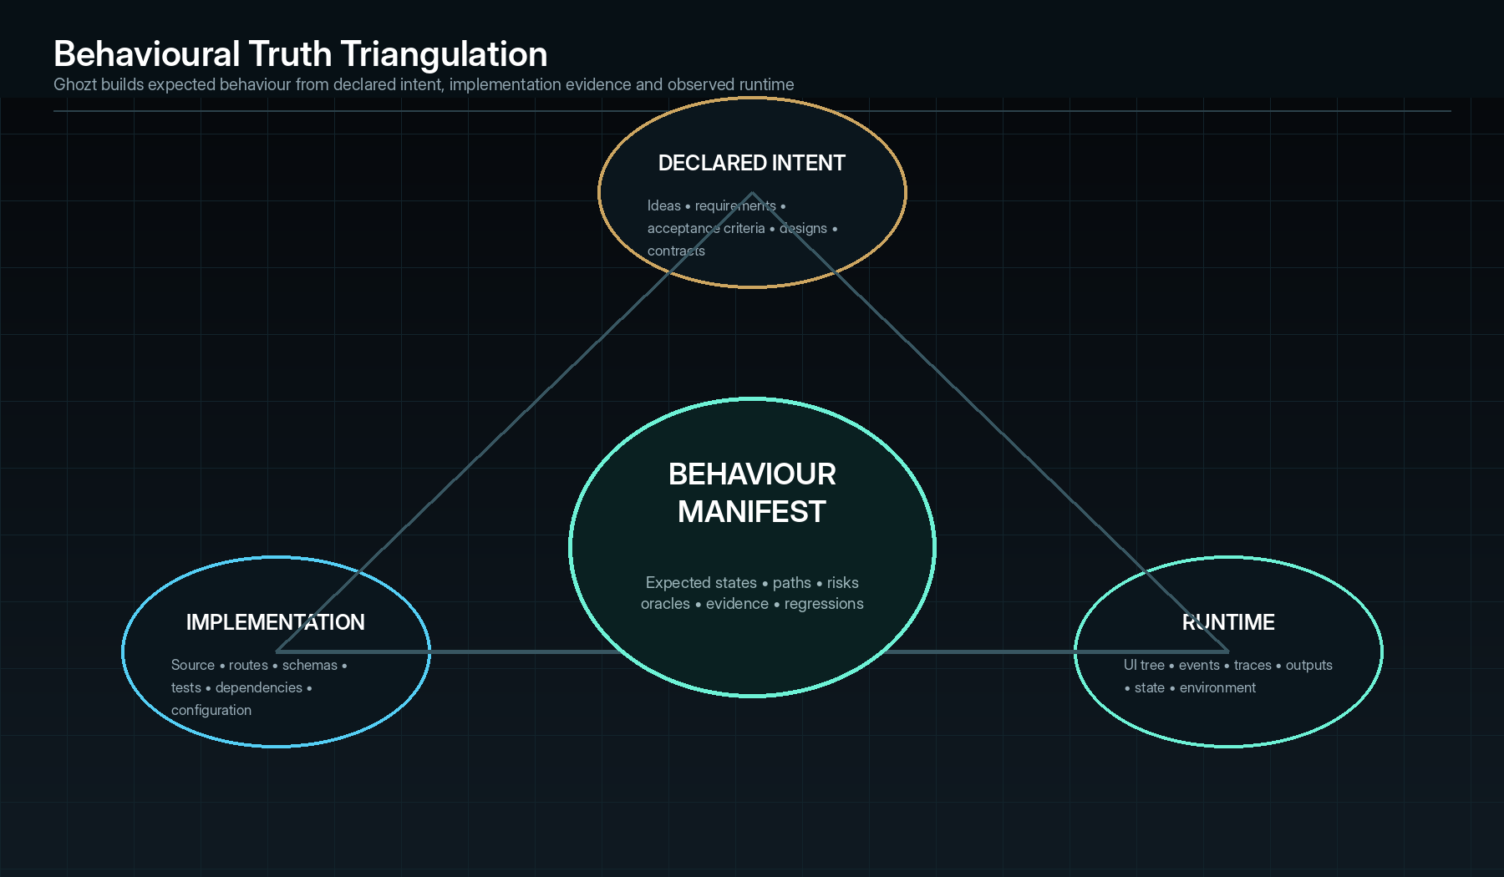
Behavioural truth is not accepted from one source; it is triangulated from intent, implementation and runtime.
05 • GOVERNANCE FOUNDATION

Canonical operating doctrine
Stage | System meaning | Required record
Structure | Define entities, roles, workflows, data, authority, scope, expected behaviour and evidence. | Manifest version, ownership, data shape, risk and verification contract.
Validation | Check inputs, assumptions, dependencies, target health, current state and permission. | Pre-flight result, blockers, warnings, environment snapshot and approval requirement.
Execution | Perform approved actions through services, adapters or agents. | Actor, tool, parameters, target, action class and execution result.
State | Update the record of truth after each material action. | Before state, after state, owner/status and next action.
Event | Emit time-ordered actions, decisions, outputs and evidence. | Event ID, timestamp, source, correlation, payload and evidence references.
Audit | Review actions, failures, approvals, findings and outcomes. | Verification result, reviewer, exceptions, clearance and immutable history.

Non-negotiable constraints
- No hidden logic.
- No untracked execution.
- No AI authority without policy.
- Every claim of completion requires evidence against actual state.
- Sensitive actions require role control, logging and reversible or reviewable operation where possible.
- Missing inputs block execution and create a visible task.
- Low-confidence AI output routes to human review.
- Integration failure records the fault and uses policy-controlled retry.
- Permission failure denies the action and records the attempt.
- Every meaningful workflow defines inputs, outputs, owner, permissions, risk, failure state and verification method.
06 • TECHNICAL VOCABULARY

Definitions and canonical identifiers
Term | Definition
Target | The application, service, algorithm, system, environment or artefact under examination.
Target Build | A uniquely identifiable version, commit, package, configuration and dependency set.
Authority Grant | A record describing who authorised which actions against which target and environment for what period.
Behaviour Manifest | A versioned graph of intended entities, workflows, inputs, outputs, states, permissions, risks, oracles and evidence requirements.
State Lattice | The connected representation of expected, discovered and observed states, transitions, components and evidence.
Sweep | A governed examination plan and run across selected scope.
Action | A permissioned operation issued by a human, service or agent.
Event | A timestamped material observation, decision, action, state delta or result.
Evidence Artefact | A captured item such as log, trace, screenshot, recording, payload, state snapshot, file or metric series.
Evidence Bundle | A manifest of evidence artefacts, provenance, hashes and relationships supporting a finding or decision.
Deviation | A difference between actual and expected behaviour that has not yet been confirmed as a fault.
Fault | A confirmed deviation under recorded conditions.
Phantom | An intermittent or condition-dependent deviation not yet reliably reproduced.
Fault Fingerprint | A normalised signature used to cluster equivalent or related failures.
Reproducer | The minimal known preconditions, actions, inputs and environment necessary to trigger a fault.
Reproduction Envelope | The range of conditions and repetitions under which the fault appears, disappears or changes.
Counterfactual Branch | A controlled variation of the observed sequence or conditions used to test causal hypotheses.
Regression Guard | A durable automated assertion derived from a feature contract or confirmed fault.
Fix Brief | A bounded, evidence-linked specification for repairing a fault and verifying the change.
Clearance Policy | A versioned set of release gates, weighting, mandatory evidence, exception and approval rules.
Clearance Decision | A signed outcome: Cleared, Conditionally Cleared, Clearance Denied, Blocked or Expired.

Identifier pattern
TGT-000001 target BLD-000001 build
AUT-000001 authority grant MAN-000001 behaviour manifest
SWP-000001 sweep/run ACT-000001 action
EVT-000001 event EVD-000001 evidence artefact
DEV-000001 deviation FLT-000001 fault
RPR-000001 reproducer CFX-000001 counterfactual branch
FXB-000001 fix brief RGR-000001 regression guard
CLR-000001 clearance RPT-000001 report

Identifiers remain immutable. Human-readable names may change, but references, evidence and audit records continue to resolve to the original entity.
07 • LAYERS AND PLANES

System architecture
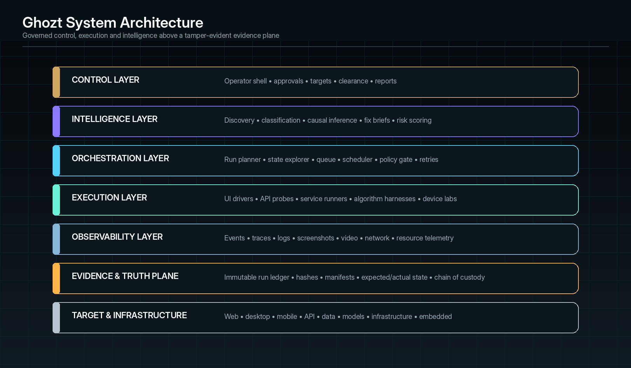
Reference logical architecture. Implementations may combine services physically while preserving contract and audit boundaries.
Layer / plane | Primary components | Responsibilities
Control Layer | Desktop/web shell, project registry, approvals, run board, report and clearance UI. | Operator commands, visibility, ownership, policy decisions and state.
Intelligence Layer | Discovery, planning, classification, causal analysis, recommendation and report agents. | Supervised inference, prioritisation, drafting and monitoring.
Orchestration Layer | Planner, scheduler, queue, state machine, budget manager, policy gate, retry and cancellation. | Deterministic run coordination and safe resource allocation.
Execution Layer | UI drivers, browser/mobile/desktop adapters, API runners, algorithm harnesses, environment controllers and code services. | Permissioned actions against target systems.
Observability Layer | Event intake, OpenTelemetry-style traces, log adapters, screenshots/video, network, process, resource and state probes. | Capture actual execution and synchronise evidence.
Evidence & Truth Plane | Manifest registry, event ledger, artefact store, hash service, finding store, chain of custody and report provenance. | Persistent record of expected, observed, inferred and decided truth.
Target & Infrastructure | Applications, services, repositories, devices, containers, data stores and CI/CD. | Systems being examined and environments supporting execution.

Cross-cutting services
- Identity, authentication, authorisation and secrets.
- Policy and approval evaluation.
- Clock synchronisation, correlation IDs and trace context.
- Encryption, retention, redaction and legal hold.
- Schema/version registry and migration.
- Adapter and capability registry.
- Notification and backlog integration.
- Telemetry, health, diagnostics and self-test.
- Licensing/edition controls only if introduced later; never intermixed with evidence truth.
08 • SEPARATION OF AUTHORITY

Control plane, execution plane and evidence plane
Plane | May decide | May execute | Must record
Control plane | Scope, policy, approval, target selection, run budget, report and clearance. | Only through authorised services; never direct hidden action. | Operator identity, decision, policy source, target, reason and outcome.
Intelligence plane | Recommendations, classifications, plans, hypotheses, fix drafts and summaries. | No sensitive execution without a service call that passes policy. | Inputs, model/agent version, tools, assumptions, confidence and evidence references.
Execution plane | No independent product policy; it evaluates local preconditions. | Only adapter-specific actions inside the granted scope. | Exact command/tool call, parameters, before/after state, output and failures.
Evidence plane | No operational action. | No target mutation. | All artefacts, hashes, relationships, transformations, access and verification.

ARCHITECTURE PRINCIPLE
A reasoning model may select or recommend an action, but the action is executed by a bounded service that re-validates target, environment, permission, budget and current state. The resulting event and evidence are returned to the reasoning loop.

09 • IDEA TO CERTIFIED BUILD

End-to-end method
01 | Receive and identify — Register the product idea, repository, build, running target, environment, owner and authority grant.
02 | Extract intent — Parse specifications, acceptance criteria, designs, contracts, tests and developer instructions into candidate expected behaviour.
03 | Discover implementation — Analyse source, routes, schemas, dependencies, configuration, tests and build artefacts.
04 | Observe runtime — Launch or connect to the target, map accessible surfaces and capture baseline state.
05 | Construct manifest and lattice — Reconcile intent, implementation and observation into versioned expected and discovered nodes, transitions, risks and evidence contracts.
06 | Plan the Sweep — Prioritise paths according to change, risk, novelty, dependency, historical faults, coverage value, cost and permission.
07 | Validate and approve — Check inputs, target health, reset/rollback, adapters, budgets and high-risk actions.
08 | Execute and observe — Drive UI, endpoints, services, algorithms and environments while recording events, states and artefacts.
09 | Detect deviations — Compare actual results to exact, tolerant, invariant, metamorphic, differential or statistical oracles.
10 | Investigate — Fingerprint, cluster, replay, minimise, repeat and test counterfactual factors.
11 | Recommend and repair — Create an evidence-bound Fix Brief and permit a human or bounded code agent to implement.
12 | Verify and remember — Reproduce the original failure, exercise adjacent paths and create or update regression guards.
13 | Report and clear — Generate raw and human-readable outputs, evaluate release policy and issue a signed decision.
14 | Learn without hiding — Update manifests, path statistics and prioritisation while preserving version history and human review.
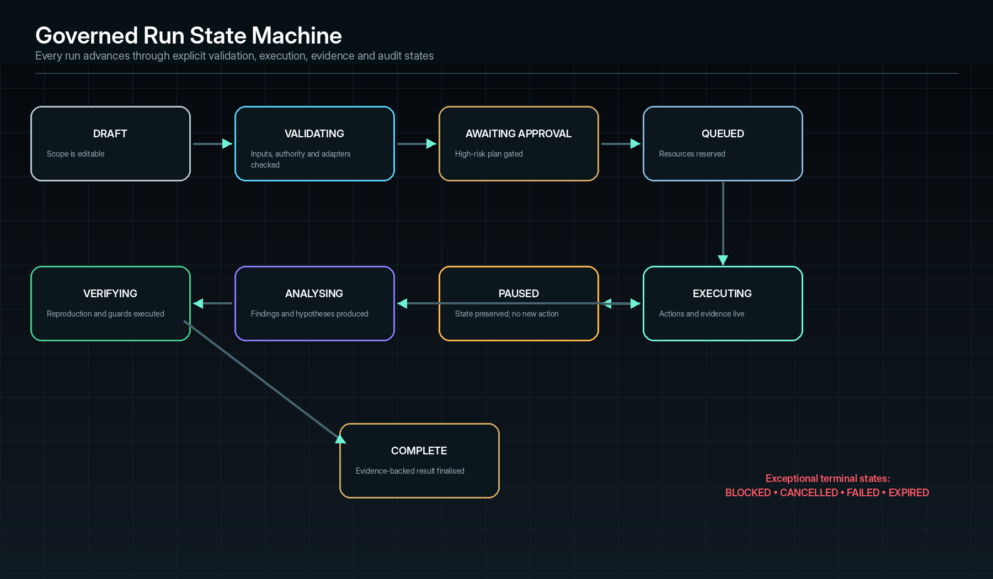
A Sweep advances through explicit states; partial, blocked and failed outcomes are preserved rather than collapsed into generic completion.
10 • SAFE ENTRY INTO THE SYSTEM

Target registration and authority
Registration field | Purpose
Target identity | Stable ID, product name, type, owner, criticality and business context.
Build identity | Commit, package digest, version, branch, configuration, dependency lock, schema and deployment ID.
Launch/connect method | Executable, URL, command, container, device, service discovery or API descriptor.
Environment class | Local, simulation, test, staging, production or external authorised target.
Authority grant | Authoriser, grantee, scope, action classes, data classes, expiry and evidence.
Credentials/secrets | Reference to protected provider, allowed use and rotation state; never embedded in test scripts.
Reset and rollback | Snapshot, transaction, fixture, seed, database restore, teardown and safe-stop procedures.
Observability access | Logs, traces, metrics, process, network, database, code coverage and crash artefacts.
Data sensitivity | Public, internal, confidential, personal, regulated or restricted; retention and redaction.
Resource budget | CPU, memory, network, device, concurrency, time, storage and monetary cost.
Exclusions | Out-of-scope paths, destructive resources, third parties and legal/contractual restrictions.

Pre-flight validation
- Verify target/build identity and prevent accidental examination of a different environment.
- Test launch, authentication, health, instrumentation and reset hooks.
- Confirm every requested action class is allowed by the authority grant.
- Estimate possible side effects and resource cost.
- Detect production, financial, messaging, deletion, privacy and external-party actions.
- Create an evidence-capture plan and verify available storage.
- Block or require approval when any mandatory input, permission, reset method or evidence capability is missing.
11 • MANIFEST CONSTRUCTION

Behavioural truth triangulation
Ghozt does not assume that product documentation, source code, tests or runtime behaviour is independently authoritative. Each source may be incomplete, stale or wrong. The Behaviour Manifest therefore records provenance and confidence for every expected entity, workflow, state and oracle.
Input source | Extracted evidence | Potential conflict
Idea / natural-language brief | Goals, users, features, constraints, implied workflows and acceptance intent. | Ambiguity, missing error states and untestable aspirations.
Formal requirements / acceptance criteria | Explicit preconditions, actions and expected outcomes. | May lag implementation or omit non-functional behaviour.
Design files / screenshots | Visible screens, controls, labels, navigation and visual expectations. | Static visuals may not define logic or all states.
Source code | Routes, functions, branches, events, schemas, permissions, errors and dependencies. | Implementation may itself be defective and should not define expected behaviour alone.
Existing tests | Prior assertions, fixtures, known edge cases and intended contracts. | Tests can be stale, narrow or falsely passing.
API / schema contracts | Endpoints, types, status codes, required fields and compatibility. | Runtime can diverge from specification.
Runtime observation | Actually reachable UI, endpoints, state and outputs. | Observed defective behaviour must not silently become the expected oracle.
Historical incidents / backlog | Known failures, risky areas and previous fixes. | Descriptions may be incomplete or unreproduced.

Manifest entity contract
feature_id: FTR-0142
name: Authentication / Refresh Session
owner: Identity Team
risk: HIGH
preconditions: [valid_refresh_token, network_available]
actions: [submit_login, receive_token, refresh_before_expiry]
expected_states: [authenticated, dashboard_loaded]
failure_states: [invalid_token_message, retryable_network_error]
permissions: [READ_ACCOUNT, CREATE_SESSION]
oracles: [http_contract, ui_state, session_store_invariant]
evidence_required: [trace, response, state_delta, screenshot]
regression_guards: [RGR-00091, RGR-00102]
provenance: [REQ-31, SRC-auth-service@7e91a, OBS-SWP-204]
confidence: 0.91

Conflict handling
- Intent says a state should exist, but source/runtime cannot locate it → mark Missing Implementation or Unreachable State.
- Source exposes a route or control absent from intent → mark Undeclared Behaviour for review.
- Existing test expects one result while formal contract expects another → mark Oracle Conflict; do not auto-resolve.
- Runtime repeatedly behaves differently from the manifest → create deviation; never silently rewrite the expected state.
- Low-confidence generated expectations remain Proposed until approved or supported by additional evidence.
12 • IMPLEMENTATION MAPPING

Static and build-time discovery
Discovery method | Possible outputs
Repository inventory | Languages, projects, packages, entry points, build systems, tests, assets and generated files.
Syntax / semantic analysis | Functions, classes, routes, events, state reducers, error branches, feature flags and permissions.
Dependency graph | Internal modules, external packages, services, versions, vulnerabilities and licence metadata where configured.
Route and endpoint extraction | UI routes, controllers, RPC methods, queue topics, webhooks and handlers.
Schema analysis | API, database, message, configuration and file formats with compatibility relationships.
Test inventory | Unit, integration, UI, contract, performance and fixtures; owners, scope and freshness.
Change-impact analysis | Changed files, dependent components, reachable tests, high-centrality nodes and historical faults.
Build/package inspection | Binaries, manifests, signatures, resources, runtime requirements and deployment configuration.
Static policy checks | Secrets, dangerous APIs, permission mismatches, unreachable code, unchecked results and configuration drift.

Static discovery proposes structure and candidate tests. It does not assert runtime reachability or correct behaviour without execution evidence.
13 • WHAT ACTUALLY EXISTS

Runtime discovery and full endpoint sweep
Runtime discovery examines the target as executed, not merely as described. It observes reachable interfaces, state transitions, services, outputs and side effects, then reconciles them with the Behaviour Manifest.

Runtime surface discovery
Surface | Discovery techniques | Resulting graph entities
Web UI | DOM and accessibility-tree traversal, route observation, link/control extraction, storage inspection and network correlation. | Screens, controls, accessible actions, route states, forms, validation and UI-to-service edges.
Desktop UI | Window/control automation tree, process/window lifecycle, menu/shortcut discovery and file/IPC observation. | Windows, controls, commands, dialogs, background services and external effects.
Mobile UI | View hierarchy, navigation, gestures, permissions, lifecycle, deep links and background-task observation. | Screens, states, device conditions, permission branches and platform interactions.
API/service | OpenAPI/GraphQL/RPC descriptors, traffic observation, source route extraction and service discovery. | Endpoints, methods, contracts, auth, error variants, dependencies and state effects.
Database/data | Schema introspection, controlled query observation, transaction hooks, CDC/logical events and before/after snapshots. | Tables, collections, fields, constraints, lineage, mutations and invariants.
Queue/event systems | Topic/subscription inventory, message schema, publish/consume trace and retry/dead-letter observation. | Topics, messages, consumers, delivery states and failure paths.
Algorithms/models | Harness registration, callable discovery, model metadata, dataset contracts and output sampling. | Inputs, parameters, outputs, invariants, versions, seeds and performance nodes.
Infrastructure | Process/container/service inventory, health endpoints, configuration and deployment events. | Services, hosts, resources, probes, dependencies, rollout and rollback states.

Endpoint sweep method
01 | Enumerate — Merge endpoint candidates from contracts, source, runtime traffic, service discovery, client code and historical evidence.
02 | Classify — Identify method, auth, statefulness, side effects, data sensitivity, cost, idempotency and dependency risk.
03 | Generate — Construct valid, boundary, invalid, missing, malformed, duplicate, replayed, unauthorised and concurrency inputs.
04 | Sequence — Test endpoints individually and inside real workflows, preserving session, data and dependency state.
05 | Observe — Capture response, latency, headers, body/schema, downstream calls, events, data mutations and user-visible effect.
06 | Compare — Evaluate contract, invariant, differential, statistical and workflow oracles.
07 | Recover — Reset state, roll back transactions, restore fixtures or route unsafe conditions to review.
08 | Record — Create path coverage, deviations, evidence bundles and durable regression cases.

Reachability classifications
Classification | Meaning
Discovered / unattempted | An entity is known from intent, source or observation but has not been exercised.
Reachable | The entity was reached under recorded preconditions.
Conditionally reachable | The entity requires a role, feature flag, device, data or environment condition.
Blocked | Execution is prevented by missing input, dependency, permission or target state.
Excluded | Explicitly outside the authority grant or current Sweep.
Unreachable candidate | Repeated supported attempts cannot reach an expected entity; requires review.
Orphan behaviour | Runtime behaviour exists without corresponding declared intent.

14 • UNIFIED BEHAVIOUR GRAPH

State Lattice technical model
The State Lattice stores expected, discovered, observed, inferred and decided relationships without collapsing them into one truth category. Each node and edge has provenance, temporal validity, confidence and evidence references.
Graph object | Key fields
Node | node_id, target/build, type, canonical name, attributes, expected status, observed status, risk, owner, provenance, first/last seen and evidence.
Transition edge | edge_id, from/to, action, precondition, guard, permission, side effects, expected result, observed result, frequency and evidence.
Temporal event edge | source event, destination event, correlation, ordering confidence, clock source and trace context.
Dependency edge | caller/callee, data dependency, ownership, version and change impact.
Causal hypothesis edge | candidate cause, effect, mechanism, supporting evidence, contradicting evidence, counterfactual tests and confidence.
Coverage record | planned, attempted, reached, verified, failed, blocked, waived, excluded and freshness.
Evidence binding | artefact ID, capture method, source, time range, hash, redaction, transformation and relevant graph region.

Truth dimensions
Dimension | Values | Rule
Origin | Declared, extracted, observed, inferred, human-decided. | Origin remains visible; inference never overwrites observation.
Temporal validity | Introduced, first seen, last verified, superseded. | Coverage expires according to policy and change impact.
Build scope | Build, branch, environment, platform and configuration. | Evidence is never reused across materially different builds without explicit compatibility.
Confidence | Measured or calibrated score plus basis. | No precision without explanation of the evidence and model.
Authority | Permitted, blocked, excluded, approval required or expired. | The graph may know a path exists while refusing to execute it.
Evidence strength | None, partial, sufficient, sealed and independently reviewed. | Clearance gates may require a minimum evidence class.

Graph evolution
- A new build starts from the prior manifest and lattice, then applies source/change diff and runtime validation.
- Nodes and edges are versioned rather than destructively replaced.
- Historical evidence remains bound to the build on which it was captured.
- Changed or dependency-affected nodes lose freshness and are prioritised for re-verification.
- Confirmed faults add regression edges and influence future exploration priority.
- Human corrections to intent or classification are recorded as decisions with source and reason.
15 • RISK-WEIGHTED STATE SEARCH

Autonomous exploration engine
The exploration engine selects the next permissible action from the frontier of reachable states. It combines deterministic rules with optional learned prioritisation, while policy and budget constraints remain authoritative.

Candidate-action score
Priority(a) =
wR × Risk(a)
+ wC × ChangeImpact(a)
+ wN × Novelty(a)
+ wG × ExpectedCoverageGain(a)
+ wD × DependencyCentrality(a)
+ wH × HistoricalFaultLikelihood(a)
+ wU × UncertaintyReduction(a)
- wK × ExecutionCost(a)
- wS × SideEffectRisk(a)
- wF × RecentFailurePenalty(a)

Weights are versioned per Sweep profile and may be tuned from historical results. A policy gate removes actions that are unauthorised, destructive beyond scope, unsupported by reset/rollback or outside the active resource budget.

Exploration strategies
Strategy | Use
Breadth-first state discovery | Map major surfaces quickly and establish baseline reachability.
Depth-first workflow traversal | Follow long business processes and multi-step failure states.
Model-based testing | Generate paths from the Behaviour Manifest and State Lattice.
Changed-area testing | Prioritise nodes affected by source, dependency, schema or configuration changes.
Risk-based testing | Prioritise critical business, safety, data, security and release paths.
Coverage-guided exploration | Prefer actions that reach unseen code, state, routes or combinations.
Property/fuzz-guided search | Mutate inputs and sequences to break invariants or expose boundary failures.
Historical-fault-guided search | Revisit high-failure areas, similar fingerprints and previous regression zones.
Active-learning prioritisation | Select tests expected to reduce uncertainty about behaviour or cause.
Pairwise/combinatorial generation | Cover high-value combinations without exhaustive Cartesian explosion.
Monte Carlo / stochastic sequence testing | Explore non-deterministic or very large state spaces under repeatable seeds.
Adversarial user simulation | Exercise impatient, repetitive, out-of-order and contradictory action patterns under authorisation.

Action constraints
- Maximum depth, action count, elapsed time, concurrency and resource use.
- Allowed action classes and data classes.
- Environment-specific deny rules.
- Required preconditions and reset/rollback capability.
- Rate limits and external-service budgets.
- Loop detection, duplicate-state detection and diminishing-return stop conditions.
- Human approval checkpoints.
- Minimum evidence requirements before a result can be reported.

Coverage accounting
WeightedCoverage =
Σ(weight_i × verified_i)
/ Σ(weight_i × in_scope_i)
UnknownRisk = Σ(weight_i for untested_or_blocked_i) / Σ(weight_i for in_scope_i)
A high WeightedCoverage cannot issue clearance when mandatory gates fail
or UnknownRisk exceeds the policy threshold.

16 • FULL-STACK TEST MODALITIES

Validation registry
Ghozt treats each validation method as a registry-backed module with declared inputs, outputs, target capability, risk, execution adapter, oracle types, evidence requirements and failure modes.
Modality | Scope | Minimum evidence
Unit | Functions, classes and small modules. | Assertions, code coverage, mutation sensitivity, fixtures and timing.
Component | UI or service component in controlled isolation. | Rendered states, events, accessibility, contracts and snapshots.
Integration | Boundaries between modules, services and dependencies. | Calls, schemas, data, errors, retries and state consistency.
UI functional | Controls, navigation, forms, visual state and accessible behaviour. | Screen/control tree, video, screenshots, events and expected state.
Workflow / end-to-end | Business sequence across layers. | Actions, services, data, outputs and user-visible completion.
API / contract | Endpoints, schemas, auth, status and side effects. | Request/response, traces, data mutations and contract diff.
Database / data integrity | Schema, constraints, transactions, lineage and reconciliation. | Queries, snapshots, checksums, invariants and rollback.
Algorithm | Correctness, invariants, boundaries, complexity and determinism. | Inputs, outputs, seed, reference, property and timing.
ML / probabilistic | Quality, calibration, robustness, drift and reproducibility. | Dataset/model versions, metrics, slices, distributions and confidence.
Security authorised | Authentication, authorisation, input handling, secrets and attack surface. | Scope, payloads, findings, proof and containment.
Privacy | Collection, purpose, access, minimisation, retention and redaction. | Data-flow evidence, policy result and exceptions.
Accessibility | Keyboard, semantics, focus, contrast, scaling and assistive technology. | Audit, interaction evidence and affected controls.
Visual regression | Layout, colour, text, images and responsive rendering. | Reference/current image, diff mask, threshold and review.
Performance | Latency, throughput, CPU, memory, storage, rendering and network. | Metrics, traces, profiles and thresholds.
Load / stress / soak | Behaviour under sustained or extreme demand. | Workload, errors, saturation, recovery and resource trend.
Concurrency / race | Parallel actions, ordering and consistency. | Schedule, locks, events, state divergence and reproduction.
Reliability / recovery | Crash, restart, dependency loss and retry. | Fault injection, state preservation, recovery time and evidence.
Chaos / resilience | Controlled failure of dependencies, networks or resources. | Injected condition, blast radius, fallback and recovery.
Compatibility | OS, browser, device, resolution, locale, dependency and version matrix. | Environment manifest and result comparison.
Installation / update / uninstall | Packaging, prerequisites, migration, repair and cleanup. | System changes, restart, rollback and residual artefacts.
Deployment smoke | Health, configuration, data migration, critical routes and rollback. | Deployment ID, probes, smoke paths and gate result.
Backup / restore | Backup completeness, integrity and recovery objectives. | Backup ID, restore target, reconciliation and loss window.
Observability validation | Logs, traces, metrics and alerts correspond to real events. | Injected event, emitted telemetry, correlation and notification.
AI agent evaluation | Role, tool use, policy, grounding, determinism and failure handling. | Inputs, model, tool calls, outputs, approval and evidence.
Report/certificate validation | Claims, evidence links, redaction, layout and signatures. | Source graph, export checks and immutable digest.

17 • EVERY CONTROL, STATE AND SEQUENCE

UI and workflow examination

UI discovery and coverage
- Enumerate screens, windows, dialogs, routes, menus, controls, accessible names, roles, states and actions.
- Detect interactive elements that are visually present but inaccessible, disabled unexpectedly or disconnected from handlers.
- Capture control inventory per build and diff added, removed, renamed or relocated behaviour.
- Generate tests for valid, empty, invalid, boundary, repeated, rapid, interrupted and out-of-order input.
- Exercise keyboard, pointer, touch/gesture where applicable, shortcuts, focus, scroll, drag/drop and resize.
- Test role, permission, loading, error, offline, empty, degraded, timeout, cancellation and recovery states.
- Verify responsive layout, DPI/scaling, multi-monitor, theme and localisation variants.
- Correlate each UI action to network, service, state and output evidence.

Expected-output oracles
Oracle | Example
Exact state | Control text, enabled state, route, database value or status must match.
Structural state | Required elements, relationships or schema exist even when values vary.
Visual tolerance | Layout/image difference remains within approved masks and thresholds.
Accessibility state | Role, name, value, focus order and action are exposed correctly.
Workflow invariant | Submitting once creates one record and one confirmation, regardless of retry timing.
Negative oracle | No external message, charge, deletion or data mutation occurs after cancellation.
Event oracle | A material user action emits the required audit and telemetry events.
Temporal oracle | The system reaches a state within a bounded duration and does not regress.

Adversarial but authorised interaction patterns
- Double-click, rapid repeated click, key repeat and simultaneous controls.
- Navigate away, close, suspend or lose network during an in-flight action.
- Submit stale forms, expired sessions, duplicated data and conflicting edits.
- Change role, locale, theme, scale or window size mid-workflow.
- Use back/forward, deep links, restored sessions and multiple windows.
- Trigger boundary focus, scroll, overflow, hidden controls and modal layering.
- Attempt prohibited action and verify denial, explanation and event recording.
18 • FULL ENDPOINT AND DEPENDENCY SWEEP

API, service and integration examination
Test family | Examples
Contract correctness | Required fields, types, enums, headers, status codes, error shapes and version compatibility.
Authentication / authorisation | Missing, invalid, expired, wrong-role, cross-tenant and delegated credentials.
Input boundaries | Null, empty, min/max, long, Unicode, malformed, duplicate, encoded and unexpected fields.
Statefulness | Ordering, session, pagination, cursors, idempotency, retries and eventual consistency.
Concurrency | Parallel create/update/delete, lost update, duplicate processing, race and lock contention.
Dependency behaviour | Timeout, partial response, malformed dependency result, circuit breaker, fallback and recovery.
Rate and resource limits | Burst, sustained load, quotas, back-pressure and client handling.
Side effects | Database, queue, file, message, billing or external call compared before/after.
Compatibility | Old/new client, schema evolution, feature flags and rolling deployment.
Observability | Trace propagation, structured logs, metrics, alerts and correlation.

Integration verification pattern
01 | Prepare — Create known data and dependency conditions or bind to a controlled fixture.
02 | Invoke — Record exact request, credentials class, timing and correlation context.
03 | Observe — Capture response and all downstream spans, messages, state mutations and visible effects.
04 | Reconcile — Compare contracts, invariants, expected side effects and forbidden effects.
05 | Recover — Verify retry, idempotency, rollback and clean-up.
06 | Bind — Attach evidence and generated regression case to the manifest edge.
19 • STATE INTEGRITY

Data, database and pipeline examination
Capability | Function
Schema diff | Compare expected, source-defined, deployed and observed schemas.
Constraint validation | Primary/foreign keys, uniqueness, nullability, domains, indexes and business constraints.
Transaction examination | Atomicity, isolation, rollback, retry and partial-failure behaviour.
State reconciliation | Compare UI/API result to database, cache, queue and derived data.
Lineage | Trace source fields through transformations to outputs and reports.
Quality profiling | Missingness, duplicates, invalid values, distribution shifts, timeliness and orphan records.
Migration testing | Forward/backward schema changes, data conversion, idempotency and rollback.
Backup/restore proof | Restore to isolated target, validate integrity and measure data-loss window.
Privacy controls | Purpose, minimisation, access, masking, deletion, retention and export.
Synthetic test data | Generate safe data preserving structure and edge conditions without copying restricted records.

Data oracle types
- Exact row/document state.
- Set equality or subset/superset relationship.
- Aggregate reconciliation and checksums.
- Referential and business invariants.
- Monotonicity, conservation or balancing equations.
- Tolerance and rounding rules.
- Temporal freshness and ordering.
- Differential comparison with a trusted implementation or previous release.
- Metamorphic relation where exact output is unavailable.
20 • LOGIC BEYOND THE UI

Algorithm and machine-learning laboratory
The Algorithm Lab allows Ghozt to examine standalone logic, services, optimisation routines, parsers, transformations, strategies and probabilistic models using the same evidence, reproduction and clearance system as application workflows.

Algorithm harness contract
harness_id: ALG-0041
subject: pricing_engine.calculate_quote
version: build BLD-219 / commit 7e91a
input_schema: QuoteRequest@v3
output_schema: QuoteResult@v3
oracle_types: [exact_reference, invariants, metamorphic, tolerance]
seeds: [1001..1100]
resource_budget: {cpu_ms: 250, memory_mb: 512}
evidence: [inputs, output, reference_diff, trace, timing, environment]
side_effect_policy: NONE

Deterministic algorithm methods
Method | Purpose
Example-based | Validate known cases and accepted reference outputs.
Boundary/value analysis | Exercise minimum, maximum, zero, negative, overflow, precision and type boundaries.
Property-based | Generate inputs and assert invariants across a broad domain.
Metamorphic | Verify expected relationships under transformations when an exact oracle is unavailable.
Differential | Compare independent implementations, versions or reference services.
Mutation testing | Alter implementation logic to test whether the suite detects meaningful faults.
Symbolic/concolic assistance | Generate path-driving inputs where supported by language/tooling.
Fuzzing | Explore malformed, random or grammar-based inputs under containment.
Complexity profiling | Measure scaling with input size and detect unexpected asymptotic or resource changes.
Determinism testing | Repeat with identical state and seed to detect hidden variance.

Probabilistic / ML methods
Method | Purpose
Dataset and feature versioning | Bind outputs to exact training/evaluation data, preprocessing and feature definitions.
Seed and environment capture | Record random seeds, hardware, libraries and model artefacts.
Slice evaluation | Measure behaviour across relevant cohorts, conditions and edge cases.
Calibration and confidence | Compare predicted confidence to observed outcome and detect overconfidence.
Robustness | Perturb inputs, noise, order, missing values and adversarially relevant conditions under policy.
Drift | Compare input, feature and output distributions against approved baselines.
Regression | Detect quality loss across model or dependency versions.
Latency/resource | Measure inference time, memory, throughput and saturation.
Metamorphic relations | Check stable relationships when exact labels are unavailable.
Human review workflow | Route low-confidence, high-impact or disputed outputs to bounded review.

Algorithm finding outputs
- Exact input, parameters, seed, dataset/model/library/build identity and environment.
- Actual output, expected/reference output and comparison method.
- Invariant/property violation or statistical evidence.
- Reproduction rate and sensitivity to factors.
- Performance/resource profile.
- Recommended logic, data, model, threshold or test change.
- Regression case and acceptance gate.
21 • BEHAVIOUR UNDER PRESSURE

Performance, reliability and resilience examination

Performance dimensions
Dimension | Measurements | Evidence and analysis
Latency | End-to-end, UI response, network, service span, database, queue and algorithm stage. | Percentiles, distributions, trace waterfall, cold/warm comparison and threshold source.
Throughput | Requests, jobs, messages, workflows or model inferences per time. | Workload definition, saturation point, errors and resource correlation.
CPU / GPU | Process, thread, function, render and accelerator utilisation. | Profiles, hot stacks, frame timing and build comparison.
Memory | Working set, allocations, heap, retained objects, GPU memory and leaks. | Time series, allocation profile, snapshots and growth rate.
Storage / I/O | Reads, writes, latency, queue depth, cache and disk growth. | Operation trace, capacity risk and cleanup behaviour.
Network | DNS, connection, TLS, transfer, retransmission, bandwidth and offline behaviour. | HAR/trace, dependency, payload and environment.
Render responsiveness | Frame time, input delay, layout, virtualisation and dropped frames. | Interaction recording, frame timeline and visual context.
Energy / thermal | Battery, temperature, throttling and sustained device behaviour where supported. | Device telemetry, workload and recovery.

Performance baselines
- Thresholds may come from requirements, service-level objectives, previous approved builds, hardware profiles or statistically established baselines.
- A single average must not hide tail latency, variance, warm-up, pauses or user-visible stalls.
- The same target/build and environment manifest accompanies every comparison.
- Results distinguish regression, absolute breach, measurement noise and unavailable evidence.
- Ghozt itself adapts capture fidelity when instrumentation would materially distort the measured target, and records that change.

Reliability and fault-injection catalogue
Injected condition | Verification
Process crash / forced termination | State preservation, safe restart, replay protection, user messaging and evidence.
Network loss / latency / packet corruption | Timeout, retry, offline mode, cancellation, idempotency and recovery.
Dependency timeout / malformed response | Fallback, circuit breaker, bounded retry, user state and downstream consistency.
Database unavailable / deadlock | Transaction outcome, retry, error classification, no partial state and recovery.
Queue delay / duplicate / reordering | Idempotency, ordering assumptions, dead-letter handling and reconciliation.
Disk full / read-only / slow | Capture degradation, user warning, transaction safety, cleanup and restart.
Clock skew | Token/session, event ordering, schedule and evidence-correlation behaviour.
Resource pressure | Graceful degradation, admission control, back-pressure and recovery.
Configuration/secret rotation | Reload, failure message, rollback and zero secret leakage.
Update interruption | Installer recovery, version truth, migration integrity and rollback.

Soak and recurrence analysis
- Run selected workflows over hours or days under bounded resource policy.
- Detect slow memory growth, handle leaks, queue accumulation, drift, timer issues and periodic spikes.
- Correlate recurrence with clock, load, data volume, background tasks and external dependencies.
- Generate a Phantom finding when a deviation is observed but the full envelope is not yet known.
- Preserve rotating evidence so storage limits do not erase the pre-failure window.
22 • CROSS-CUTTING QUALITY

Security, privacy, accessibility and compatibility validation

Authorised security modules
Area | Examples of validation
Identity and session | Authentication paths, token expiry/refresh, logout, session fixation, multi-factor flows and recovery.
Authorisation | Role, object, tenant and action checks; direct endpoint and UI enforcement consistency.
Input handling | Injection-relevant payloads, path/file handling, deserialisation, upload and command boundaries under containment.
Secrets | Hard-coded or logged secrets, storage, transport, redaction, rotation and least privilege.
Transport and service trust | TLS/configuration, certificate handling, redirect, mixed content and service identity.
Client security | Sensitive storage, clipboard, screenshots, deep links, update trust and local permissions.
Abuse and rate control | Brute force, replay, enumeration, quotas and account/resource lockout behaviour.
Security observability | Required audit events, tamper resistance, alerts and incident evidence.

SAFETY BOUNDARY
Ghozt may coordinate authorised security testing, but the architecture does not grant permission. Security modules inherit the same target authority, environment, action-class, budget, evidence and approval controls as every other execution path.

Privacy validation
- Map data collection, transformation, sharing, storage, access, export and deletion against declared purpose.
- Verify data minimisation, masking, role access, retention, legal hold and redaction.
- Detect sensitive values in logs, screenshots, recordings, payloads, reports and model prompts.
- Test subject-access, correction, portability or deletion workflows where applicable.
- Record test-data provenance and prevent uncontrolled copying of production personal information.

Accessibility validation
- Keyboard reachability, visible focus, logical order and no keyboard trap.
- Accessible name, role, value, state, description and action for custom controls.
- Text and non-text contrast across every theme and state.
- Scaling, reflow, zoom, reduced motion, captions/transcripts and assistive-technology paths.
- Accessible alternative to graphs, heatmaps, timelines and visual evidence.
- Regression guards for critical accessible behaviour rather than one-off audit output.

Compatibility matrix
Axis | Examples
Operating system | Supported Windows editions/builds; future Linux/macOS targets where adapters exist.
Browser/webview | Engine, version, feature flags, storage/security mode and viewport.
Device | Android models/versions, screen density, hardware and permissions; future platforms.
Display | Resolution, scale, orientation, multi-monitor and colour/high-contrast mode.
Locale | Language, date/time, number/currency, timezone, text expansion and right-to-left where applicable.
Dependencies | Runtime, framework, driver, database, service and API versions.
Upgrade path | Fresh install, in-place update, skipped versions, downgrade/rollback and data migration.

23 • BLACK-BOX RECORDING

Observability and evidence capture
Ghozt’s black-box function captures enough context to reconstruct material behaviour while controlling performance, privacy and storage. Evidence is selected by policy and risk, not captured indiscriminately.
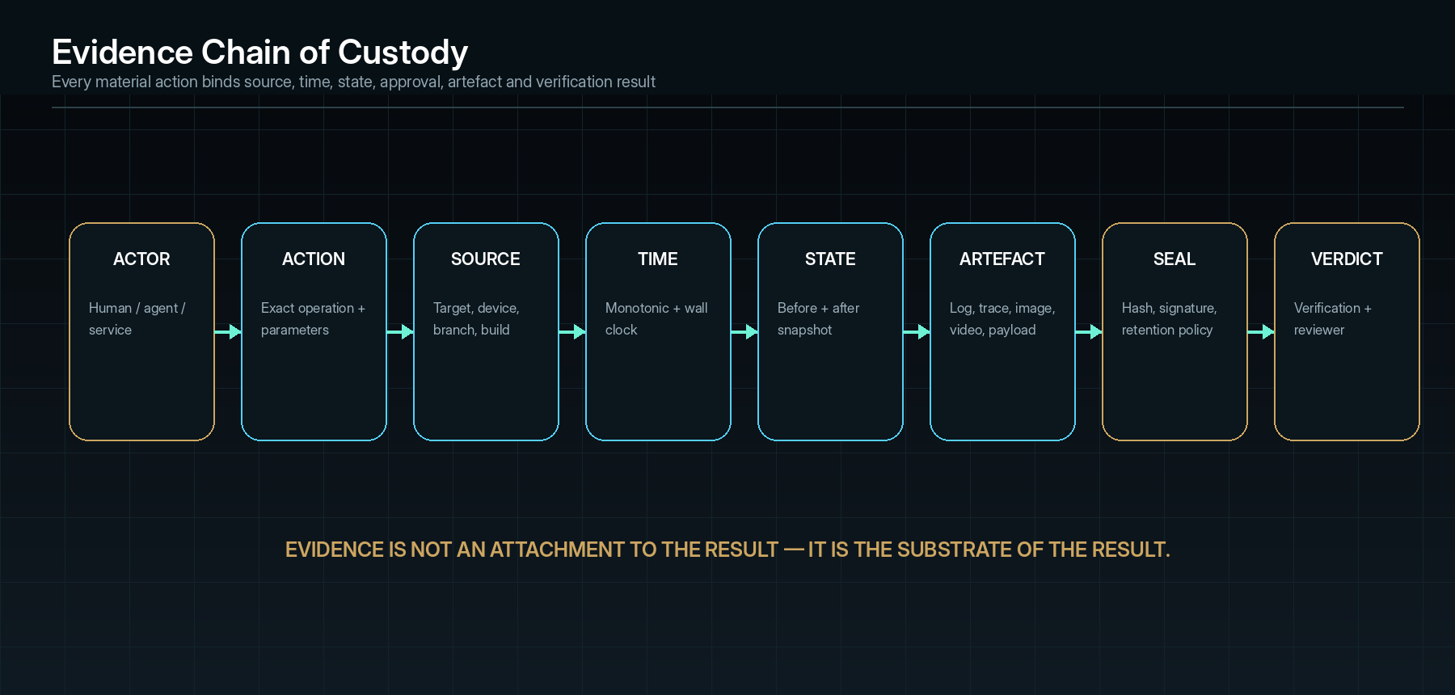
The evidence chain binds actor, action, source, time, state, artefact, seal and verdict.

Evidence sources
Source | Captured content
Application events | Structured logs, exceptions, warnings, domain events and audit records.
Distributed traces | Spans, baggage, correlations, service calls, queues and database activity.
UI evidence | Screenshots, video, control/accessibility tree, visual diff and input events.
Network evidence | Requests, responses, headers, timing, connection and permitted payloads.
State snapshots | Application state, files, registry/configuration, database records, cache and queue position.
Process/system | Processes, threads, modules, handles, CPU, memory, GPU, disk, network and crashes.
Source/build | Commit, diff, binaries, package hashes, dependencies, configuration and symbols.
Algorithm/model | Inputs, outputs, seed, dataset/model version, parameters, distribution and performance.
Agent evidence | Prompt/input contract, model/agent version, reasoning summary, tool calls, approvals and output.
Human evidence | Annotations, review, decision, waiver, approval and signature.

Adaptive capture
- Baseline mode captures low-cost structural telemetry.
- Anomaly mode increases relevant capture around a deviation.
- Forensic mode preserves a wider pre/post window, additional state and higher-fidelity media.
- Sensitive mode redacts or omits configured fields while maintaining proof that redaction occurred.
- Performance mode reduces intrusive capture and measures instrumentation overhead.
- Storage pressure mode follows policy: compress, sample, stop optional media, preserve mandatory evidence and record every omission.

Chain of custody
Field | Requirement
Source | Target, process/service, adapter and capture mechanism.
Time | Wall clock, monotonic clock, timezone and synchronisation quality.
Actor | Human, agent or service identity and role.
Acquisition | Original format, capture parameters and action correlation.
Integrity | Cryptographic digest, optional signature, immutable reference and verification.
Transformation | Every crop, redaction, conversion, extraction or annotation linked to the original.
Access | Who viewed, exported, changed classification or applied redaction.
Retention | Policy, expiry, hold, deletion evidence and backup relationship.
Relevance | Finding, event, node, edge, report and clearance relationships.

24 • CLEAR LOG CODES

Event ledger and diagnostic code system
Every material action and state change receives a stable event code and correlation context. Codes are machine-parseable, human-searchable and suitable for reports, backlogs and support.

Event code structure
GZT-{DOMAIN}-{CLASS}-{NUMBER}
Examples:
GZT-UI-ACT-0104 control action
GZT-UI-STA-0212 UI state transition
GZT-API-REQ-0301 endpoint request
GZT-API-RSP-0302 endpoint response
GZT-DAT-DEL-0408 data delta
GZT-ALG-DEV-0509 algorithm output deviation
GZT-OBS-CAP-0604 evidence capture
GZT-POL-DEN-0702 policy denial
GZT-AI-REC-0803 AI recommendation
GZT-CLR-DEN-0901 clearance denied

Canonical event record
{
"event_id": "EVT-00028411",
"code": "GZT-API-RSP-0302",
"run_id": "SWP-000204",
"target_id": "TGT-000017",
"build_id": "BLD-000219",
"timestamp_utc": "2026-08-30T12:26:42.322Z",
"monotonic_ns": 884112991230,
"actor": {"type":"agent","id":"AGT-04","role":"exploration"},
"source": {"adapter":"api-http","component":"identity-service"},
"correlation": {"trace_id":"TRC-19A","parent_event":"EVT-00028410"},
"action": {"method":"POST","path":"/api/session"},
"before_state_ref": "STA-8821",
"after_state_ref": "STA-8822",
"result": {"status":500,"duration_ms":404},
"evidence_refs": ["EVD-000084","EVD-000085"],
"severity": "HIGH",
"verification": "OBSERVED"
}

Code registry requirements
- Every code has a canonical meaning, severity defaults, expected fields and remediation owner.
- Codes are versioned; retired codes remain resolvable.
- Adapters may add namespaced codes but cannot redefine core semantics.
- A code does not replace the human message, raw payload or evidence.
- Error surfaces show code, target/build, exact operation, current impact, retry/recovery state and evidence link.
- The same code is usable in UI, logs, APIs, reports and backlog integrations.
25 • FROM DIFFERENCE TO DEFENSIBLE FAULT

Deviation detection and finding classification

Oracle evaluation pipeline
01 | Normalise — Convert actual and expected values into comparable structures while preserving originals.
02 | Apply exclusions — Use versioned masks, tolerances, volatile fields and approved non-determinism.
03 | Evaluate — Run exact, structural, invariant, temporal, visual, differential, metamorphic or statistical oracle.
04 | Classify difference — Identify missing, extra, changed, out-of-order, late, unstable, inaccessible or forbidden behaviour.
05 | Estimate impact — Trace affected users, data, dependencies, workflows and release gates.
06 | Seek confirmation — Repeat or corroborate according to risk and evidence policy.
07 | Create deviation/fault — Record actual/expected, sequence, conditions, evidence, severity, reproducibility and owner.

Severity model
Level | Technical meaning | Typical release effect
Info | Observation or improvement without incorrect behaviour. | No block; may inform optimisation.
Low | Limited incorrect behaviour with safe workaround and low impact. | Policy-dependent.
Medium | Material feature degradation, data inconsistency or recurring failure. | May block affected feature or require waiver.
High | Core workflow failure, significant data/security/reliability impact or broad scope. | Normally blocks release.
Critical | Safety, destructive data loss, severe security/privacy breach or uncontrollable production impact. | Immediate containment and clearance denial.

Finding maturity
State | Meaning
New deviation | Expected/actual mismatch observed; confirmation incomplete.
Phantom | Observed intermittently; reproduction envelope incomplete.
Confirmed fault | Evidence and policy confirm incorrect behaviour.
Reproduced | Reproducer succeeds at or above the required rate.
Cause supported | One or more causal hypotheses survive counterfactual challenge.
Fix ready | Bounded repair brief and verification plan approved.
Re-test | Change is under verification.
Verified repaired | Original and adjacent guards pass; evidence sealed.
Waived | Risk accepted under named authority, scope and expiry.
Rejected / not a fault | Evidence shows expected behaviour, test error or invalid oracle; reason preserved.

26 • STABLE FAILURE IDENTITY

Fault fingerprinting and duplicate control
A fault fingerprint enables Ghozt to recognise equivalent failures across repeated runs, environments or builds without collapsing materially different causes into one issue.

Fingerprint features
- Normalised exception type, stack frames and error code.
- Expected-versus-actual difference path and semantic category.
- Relevant State Lattice node/edge and workflow position.
- Minimal action-sequence signature.
- Input class or schema-normalised values.
- Environment/build/dependency dimensions.
- Upstream trace and downstream effect pattern.
- Data/state delta signature.
- Visual/accessibility difference region where relevant.
- Timing and concurrency characteristics.

Composite fingerprint
Fingerprint = HASH(
Normalise(exception_signature),
SemanticDiff(expected, actual),
LatticeContext(node, edge, workflow_position),
SequenceSketch(minimal_actions),
StateDeltaSketch(before, after),
DependencyTraceSketch(trace),
EnvironmentClass(environment)
)

Exact hashes support deterministic matches. Similarity embeddings or locality-sensitive signatures may identify related faults, but the UI must label these as clustered candidates until verified.

Duplicate decision
Outcome | Rule
Same fault | Equivalent reproducer, semantic diff and causal mechanism across the compared scope.
Variant | Same underlying cause with materially different environment, input or downstream impact.
Related | Similar symptom or dependency path, but cause not proven equivalent.
Independent | Distinct mechanism despite similar final message.

27 • RECONSTRUCTING THE SEQUENCE

Time alignment and deterministic replay
Ghozt aligns events from heterogeneous clocks and sources into a best-supported partial order, then uses checkpoints and recorded actions to replay the failure.

Timeline alignment
Evidence | Alignment method
Distributed traces | Trace/span parentage and propagated timestamps.
UI actions and frames | Local monotonic clock, frame time and action acknowledgements.
Application logs | Structured timestamp plus correlation ID and sequence.
Network | Request/response pairing, connection timeline and trace headers.
Database/queue | Transaction/message IDs, commit/delivery order and CDC/event sequence.
Agent actions | Tool-call ID, policy decision, service result and returned evidence.
Unsynchronised sources | Estimate offset/uncertainty from shared events; preserve partial order when exact order is unknowable.

Replay package
replay_id: RPL-000042
target_build: BLD-000219
environment_manifest: ENV-000118
checkpoint: CHK-000771
preconditions: [fixture:USR-441, network:normal, clock:2026-08-30T14:25+02]
actions: [ACT-9001, ACT-9002, ACT-9003, ACT-9004]
inputs: [INP-610, INP-611]
seeds: [44319]
dependency_stubs_or_versions: [identity-service@4.8.1]
expected_fault_fingerprint: FP-88A19
evidence_plan: [video, trace, state_delta, response]

Replay outcomes
Outcome | Meaning
Exact reproduction | Same fingerprint and material causal sequence.
Equivalent reproduction | Same semantic failure and supported cause with permitted superficial differences.
Partial reproduction | Some symptoms or enabling conditions appear; fingerprint incomplete.
Non-reproduction | Failure absent under recorded attempt; evidence contributes to the reproduction envelope.
Invalid replay | Target, checkpoint, dependency or evidence mismatch prevents a valid conclusion.

28 • MAKING THE FAILURE HOLD STILL

Reproduction minimisation and Phantom analysis
A long failing workflow is difficult to debug and fragile to automate. Ghozt therefore searches for the smallest sequence, state and input set that still produces the same material fault fingerprint.

Minimisation dimensions
Dimension | Removal / simplification strategy
Actions | Delta-debug action subsequences while preserving required order.
Inputs | Reduce fields, lengths, values, datasets and parameters.
State | Remove fixtures, records, permissions, feature flags and prior transitions.
Dependencies | Replace or remove calls; pin versions; substitute controlled stubs.
Timing | Widen or narrow waits, remove delays, vary scheduling and isolate race windows.
Environment | Reduce device, locale, theme, resolution, load, network and resource conditions.
Concurrency | Reduce workers/threads/requests while preserving the failure.
Evidence | Retain the minimum capture that still proves the fingerprint and cause.

Reproduction envelope model
Envelope(FLT) = {
required_conditions,
sufficient_conditions,
suppressing_conditions,
correlated_conditions,
attempt_count,
reproduction_count,
confidence_interval,
environment_ranges,
timing_ranges,
known_variants
}

Phantom workflow
01 | Preserve — Seal the original anomalous sequence and the pre/post evidence window.
02 | Repeat — Run controlled repetitions under the same recorded conditions.
03 | Stratify — Group attempts by environment, timing, load, data, role and dependency state.
04 | Vary — Change one candidate factor at a time where practical.
05 | Measure — Calculate reproduction rate and uncertainty; do not label random absence as repair.
06 | Escalate — Increase instrumentation or move to specialised concurrency/resource analysis.
07 | Resolve — Promote to Reproduced, retain as Phantom with known envelope, or reject with evidence.

Reproducibility score
ReproducibilityScore =
weighted_successes / weighted_valid_attempts
Weights may account for environment fidelity, checkpoint validity,
evidence completeness and fingerprint equivalence.
The score is always displayed with attempt count and confidence,
not as an isolated percentage.

29 • WHY IT BROKE, NOT ONLY WHERE

Counterfactual causal forensics
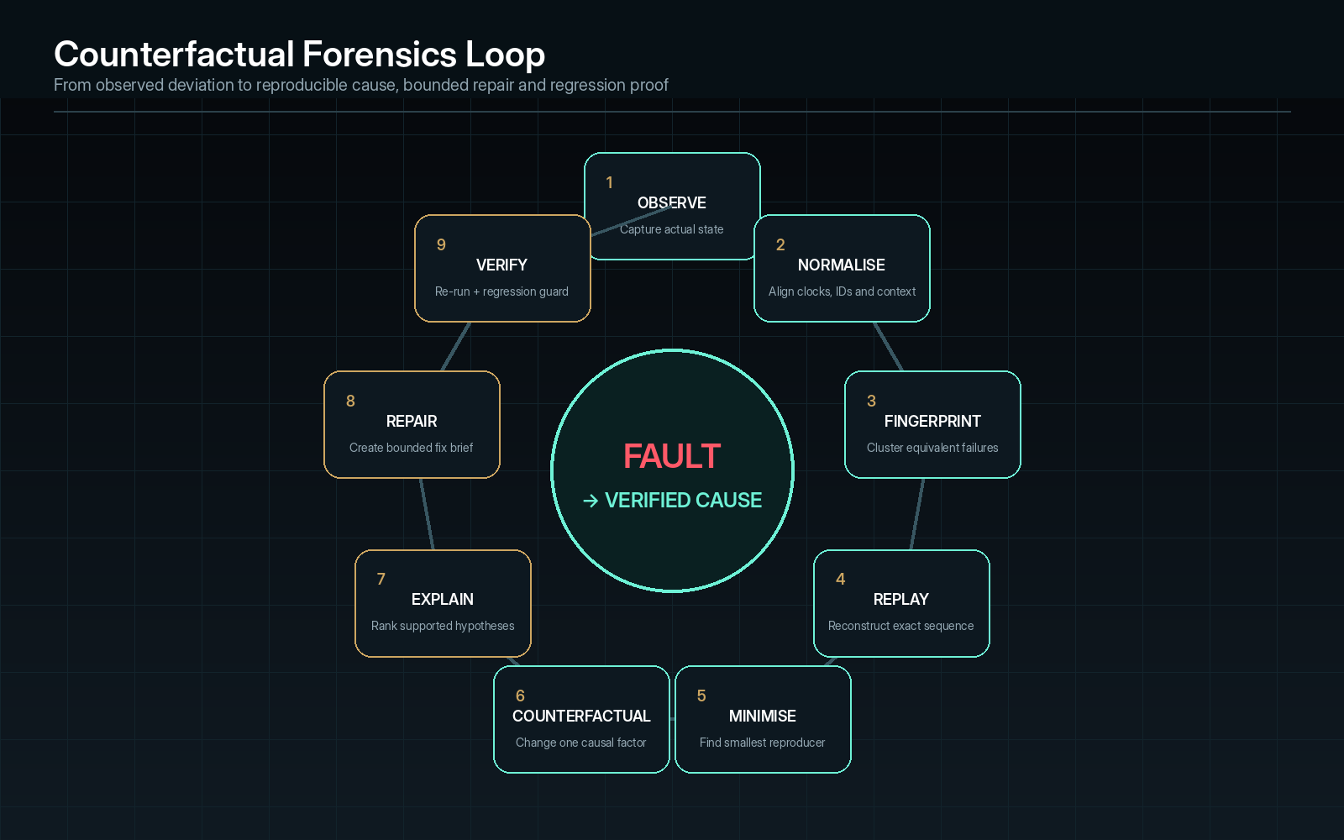
Ghozt’s forensic loop converts an observed deviation into a reproducible, challenged and verified causal explanation.
Counterfactual analysis asks whether the fault would still occur if a suspected causal factor were absent, changed or held constant while the remainder of the reproducer remained materially equivalent.

Causal hypothesis object
hypothesis_id: HYP-00019
fault_id: FLT-00217
claim: refresh token parsing returns a null identity claim
mechanism: null claim bypasses session construction and raises HTTP 500
supporting_evidence: [EVD-84, EVD-87, EVT-0A94..0A99]
contradicting_evidence: [EVD-90]
predictions:
- valid identity claim prevents the 500
- same null claim reproduces across UI and direct API path
interventions: [CFX-031, CFX-032]
confidence: 0.93
status: SUPPORTED_NOT_FINAL

Counterfactual interventions
Intervention class | Example
Input intervention | Replace only the suspected null/invalid field while preserving other request values.
State intervention | Set session/cache/database state to the hypothesised correct or faulty value.
Sequence intervention | Remove, reorder or insert one action in the reproducer.
Dependency intervention | Pin, stub, fail or alter one downstream response.
Timing intervention | Shift delay, schedule, timeout or concurrent ordering.
Environment intervention | Change version, configuration, feature flag, locale, device or resource level.
Implementation intervention | Apply a minimal temporary patch or guard in an isolated branch.
Negative control | Vary a factor not expected to affect the fault to detect experimental artefacts.

Evidence-weighted hypothesis score
CausalSupport(h) =
Σ(weight_j × supporting_test_j)
- Σ(weight_k × contradicting_test_k)
+ mechanism_consistency
+ cross_path_reproduction
- confounding_penalty
- intervention_invalidity

The score assists prioritisation; it does not erase the underlying evidence. A hypothesis may remain unresolved where intervention is unsafe, unavailable or confounded.

Causality presentation rules
- Use “observed”, “associated”, “supported”, “contradicted” and “not established” precisely.
- Do not label a last stack frame or error message as root cause without mechanism evidence.
- Show supporting and contradicting artefacts together.
- Display which factors were held constant and which changed.
- Separate counterfactual/simulated branches from historical events.
- Preserve alternative viable hypotheses until evidence rejects them.
- Require stronger causal evidence as risk and repair impact increase.
30 • FROM FORENSIC FINDING TO CONTROLLED CHANGE

Fix Brief and bounded repair execution
Ghozt’s repair system converts a supported finding into a narrow implementation contract. The goal is not simply to generate code; it is to prevent a repair agent or developer from changing unrelated logic and to define how the change will be proven.

Fix Brief contents
Field | Required content
Finding identity | Fault, fingerprint, severity, impact and affected builds.
Proven behaviour | Actual, expected, minimal reproducer and evidence.
Cause status | Supported hypotheses, confidence, contradictions and unresolved factors.
Allowed change scope | Repositories, files, modules, functions, schemas or configuration that may change.
Forbidden change scope | Security, unrelated refactors, interfaces, data migrations or product logic not authorised.
Repair strategy | One or more ranked technical approaches, expected mechanism and trade-offs.
Dependencies | Versions, contracts, migrations, feature flags and external coordination.
Required tests | Minimal reproducer, unit/property tests, adjacent workflows, regressions, performance/security checks.
Rollback | How to revert code, data and deployment changes.
Approval | Who may implement, review, merge and deploy.
Completion proof | Evidence and clearance gates required before the finding can close.

AI-assisted repair pattern
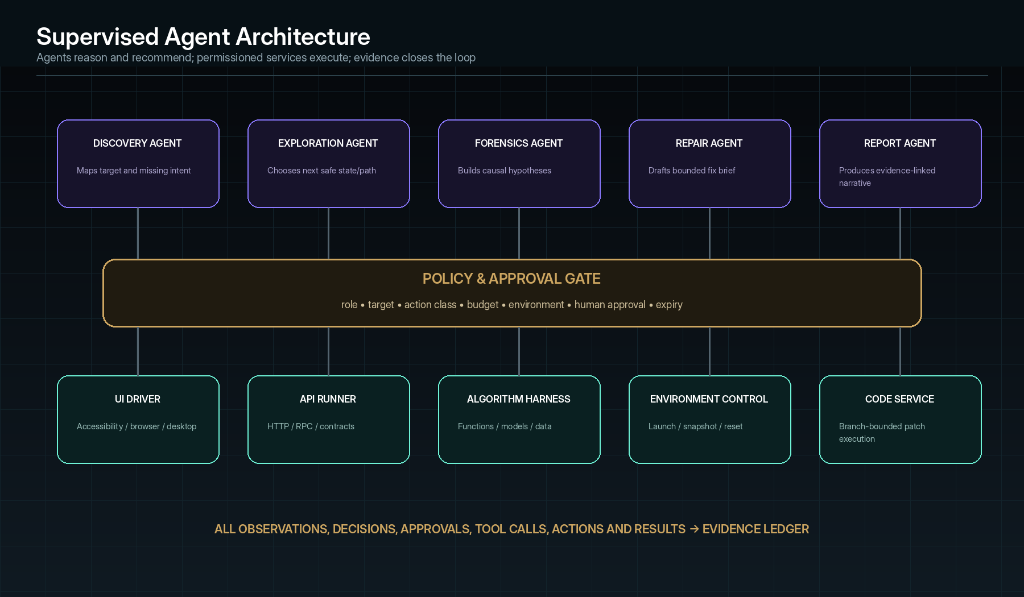
Agents remain bounded by policy; execution occurs through permissioned services and returns evidence.
01 | Observe — Repair agent receives the approved Fix Brief, source snapshot and relevant evidence.
02 | Plan — Agent proposes a minimal change plan and identifies assumptions and affected tests.
03 | Request — Policy evaluates branch, files, commands, dependencies, network and resource permissions.
04 | Execute — Code service applies changes in an isolated branch/worktree and records every file/command result.
05 | Inspect — Static checks and targeted tests run before broad re-test.
06 | Challenge — Ghozt replays the original fault and counterfactual conditions.
07 | Regress — Adjacent and historical guards run according to change impact.
08 | Review — Human receives diff, evidence, residual risk and recommendation.
09 | Promote — Merge/deploy occurs only through the project’s approval and release workflow.

Repair rejection conditions
- The proposed change exceeds allowed scope without new approval.
- The plan addresses only a symptom while the supported mechanism remains.
- Required tests cannot run or evidence capture is unavailable.
- The change weakens an oracle, deletes a guard or hides an error without justification.
- A passing result depends on test-data corruption, disabled feature or excluded path.
- New high-severity regressions or unresolved counterfactual contradictions appear.
- The agent claims success without an executed and evidenced re-test.
31 • FAULTS BECOME PERMANENT GUARDS

Regression memory and change impact
Every confirmed feature contract and repaired fault can produce a durable Regression Guard bound to the manifest and affected graph region. Guards are maintained as product knowledge, not disposable scripts.

Regression guard types
Guard type | Derived from
Exact reproducer | Minimal sequence and fingerprint of a confirmed fault.
Feature contract | Approved expected state and evidence requirement.
Invariant/property | Rule that must hold across many generated inputs.
Visual/accessibility reference | Approved structure, appearance and accessible semantics.
Performance baseline | Threshold or statistical envelope for a defined environment.
Security/privacy control | Required denial, redaction, audit or isolation behaviour.
Deployment smoke | Critical post-deployment path, health and rollback evidence.
Algorithm/model case | Input, seed, property, distribution or slice with accepted bounds.

Guard lifecycle
01 | Generate — Create from a supported finding or approved manifest contract.
02 | Validate — Prove the guard fails against the defective state where feasible and passes the repaired state.
03 | Own — Assign product area, risk, cadence and maintenance owner.
04 | Select — Use change impact, dependency and policy to choose guards for a build.
05 | Execute — Run in controlled environment and preserve evidence.
06 | Monitor — Track failure, flake, runtime, evidence completeness and value.
07 | Refresh — Update when behaviour intentionally changes; preserve old versions and decisions.
08 | Retire — Require reason, impact assessment and approval; never silently delete protection.

Mutation and false-confidence controls
- Mutation or fault seeding may verify that critical guards detect meaningful breakage.
- A guard that always passes, never reaches its assertion or no longer covers the intended node is marked ineffective.
- Flaky guards are investigated as findings, not simply retried until green.
- Stale guards lose clearance value when affected behaviour or dependencies change.
- Coverage counts distinguish executed, asserted, evidenced and independently reviewed protection.
32 • TWO AUDIENCES, ONE TRUTH

Professional reporting and raw evidence outputs
Ghozt generates concise human-readable reports and complete raw records from the same underlying manifest, event and evidence graph. The summary is not a separate narrative that can drift from the technical result.

Report families
Report | Audience | Contents
Forensic Finding Report | Developer, QA, security, architect. | Fault, impact, actual/expected, sequence, reproduction, causality, evidence, repair and guards.
Sweep Technical Report | Engineering team. | Scope, environment, methods, coverage, tests, findings, performance, limitations and raw references.
Executive Assurance Brief | Leadership/client. | Decision, major risk, affected capability, trend, residual unknowns and required action.
Release Clearance Dossier | Release authority/auditor. | Gate matrix, evidence digest, findings, waivers, signatures and target/build identity.
Algorithm Validation Report | Algorithm/ML/data team. | Harness, data/model versions, methods, results, distributions, reproducibility and limitations.
Raw Evidence Manifest | Machine/auditor. | Events, artefacts, hashes, provenance, schemas and relationships.
Machine-readable result | CI/CD, backlog and analytics. | Structured findings, tests, evidence references, severity, state and gate output.

Forensic report structure
01 | Cover and control — Product, target, build, environment, run, date, classification and authoring system.
02 | Executive finding — What failed, impact, reproducibility, current status and release implication.
03 | Scope and method — What was examined, excluded, blocked and which adapters/oracles were used.
04 | Expected versus actual — Governing contract and exact observed difference.
05 | Sequence reconstruction — Time-ordered events and divergence point.
06 | Reproduction — Preconditions, minimal steps, attempts and envelope.
07 | Causal analysis — Hypotheses, evidence, interventions, confidence and unresolved factors.
08 | Repair strategy — Bounded recommendations, risks and required change scope.
09 | Verification plan/result — Re-test, adjacent tests, regressions and evidence.
10 | Raw evidence references — Artefact IDs, hashes, provenance and appendices.
11 | Review and decision — Owner, approvals, waiver/closure and version history.

Report integrity checks
- Every factual claim resolves to observed event, state, artefact or approved manifest source.
- AI-written text is labelled as draft until reviewed when policy requires.
- No finding may appear closed if required evidence or re-test is missing.
- Broken evidence links, changed source findings and expired waivers block publication.
- Sensitive content is scanned and redacted under policy while the original remains protected.
- DOCX, PDF and machine exports carry matching report and evidence digests.
33 • EARNED, NOT ASSERTED

Release clearance and quality certification
Clearance converts technical results into a policy decision. It does not claim that software contains no defects; it states what was verified, what failed, what remains unknown and whether the declared release policy is satisfied.

Clearance inputs
Input | Examples
Mandatory features/workflows | Login, payments, data save, safety controls, core algorithms and update.
Required modalities | Unit, integration, UI, security, performance, accessibility and deployment smoke.
Risk-weighted coverage | Verified coverage of critical/high/medium/low scope.
Open findings | Count and impact by severity, reproducibility and affected gate.
Unknown risk | Untested, blocked, stale, unsupported or unavailable evidence.
Regression health | Required guards, flake, mutation effectiveness and freshness.
Performance/reliability | Thresholds, soak, recovery and resource results.
Security/privacy/accessibility | Policy-specific mandatory controls.
Waivers | Scope, reason, compensating control, approver and expiry.
Evidence quality | Completeness, integrity, chain of custody and review.

Decision model
Clearance = PASS only when:
all mandatory gates pass
AND no unwaived blocking fault exists
AND UnknownRisk <= policy limit
AND required evidence is complete and current
AND required approvals/signatures exist
Possible outcomes:
CLEARED
CONDITIONALLY_CLEARED
CLEARANCE_DENIED
BLOCKED
EXPIRED

Anti-gaming rules
- Excluded and blocked scope remains visible and does not count as passed.
- Repeated tests of the same low-risk path cannot inflate weighted coverage.
- Stale evidence loses value after relevant change or policy expiry.
- Waivers cannot silently convert faults to passes and must expire.
- A high aggregate score cannot override a failed mandatory gate.
- Clearance records policy version, target/build, evidence digest and named approvers.

Certificate contents
- Product, target/build, environment and release candidate identity.
- Clearance outcome, scope and validity period.
- Policy and gate versions.
- Verified coverage and unknown-risk summary.
- Open accepted findings and waiver conditions.
- Evidence/report digest.
- Approver identity, signature and issue time.
- Machine-verifiable reference for CI/CD or deployment system.
34 • INTELLIGENCE WITHOUT HIDDEN AUTHORITY

Supervised multi-agent architecture
Agents specialise by role and operate under input/output contracts, permission limits, tool registries, budgets and audit logs. High-risk execution requires human approval.
Agent role | Inputs | Outputs | Prohibited authority
Manifest Agent | Ideas, requirements, designs, source discoveries and runtime observations. | Proposed manifest entities, conflicts and missing intent. | Cannot silently approve expected behaviour.
Discovery Agent | Target capabilities, source/runtime inventory and prior lattice. | New nodes, edges, adapters and uncertainty. | Cannot exceed target authority.
Sweep Planner | Scope, risk, change, budgets and policy. | Ordered run plan and expected evidence. | Cannot approve its own high-risk plan.
Exploration Agent | Current state, frontier, scores and action constraints. | Next candidate action and rationale. | Cannot invoke a tool directly outside service/policy gate.
Forensics Agent | Events, evidence, fingerprint and reproductions. | Hypotheses, counterfactual plan and confidence. | Cannot label cause final without required evidence.
Repair Agent | Approved Fix Brief, source snapshot and constraints. | Patch plan or bounded change. | Cannot modify unauthorised files/branches or weaken tests.
Regression Agent | Manifest, change impact, findings and guards. | Selected/generated regression suite. | Cannot retire protection without decision.
Report Agent | Approved findings, evidence and template. | Evidence-linked draft narrative and tables. | Cannot invent findings or mark unreviewed claims as verified.
Clearance Evaluator | Policy, gates, findings, evidence and waivers. | Deterministic decision recommendation. | Cannot sign or waive risk unless assigned authority.

Canonical agent pattern
01 | Observe — Receive bounded context and current state.
02 | Classify — Identify entity, risk, confidence and applicable policy.
03 | Draft — Produce plan, hypothesis, report text or repair proposal.
04 | Recommend — Explain action, evidence, assumptions and expected effect.
05 | Request approval — Route high-risk or policy-gated action.
06 | Execute through service — Use only granted tools and revalidated parameters.
07 | Record evidence — Store input/output, tool result, state change and verification.

Agent-quality controls
- Versioned prompts/instructions, models, tools and retrieval sources.
- Structured output validation and schema enforcement.
- Grounding to manifest, source and evidence; unsupported claims flagged.
- Confidence and low-confidence review routing.
- Deterministic replay where possible; seeds/settings captured.
- Red-team and negative tests for permission bypass, fabricated completion and tool misuse.
- Cost, latency and token/resource budgets.
- Separation of recommendation, approval, execution and verification roles.
- No private chain-of-thought dependency in the evidence record; preserve concise, reviewable reasoning summaries and cited evidence.
35 • TRUSTWORTHY EXAMINATION

Security architecture and data protection
Ghozt may receive source code, credentials, application data, screenshots, network payloads, logs and AI context. Its own security and privacy posture must therefore be stronger than a normal development utility.

Security controls
Control area | Required architecture
Identity | Local or enterprise identity, strong authentication, session control and device trust where configured.
Authorisation | Role- and attribute-based access to projects, targets, action classes, evidence, secrets, reports and clearance.
Secrets | External secret-provider references, least privilege, short-lived credentials, no plaintext logs and rotation status.
Isolation | Per-run processes/containers/accounts, network policy, filesystem sandbox, branch/worktree isolation and device reset.
Encryption | Encrypted transport; encrypted sensitive artefacts and metadata at rest; key separation and rotation.
Integrity | Content-addressed artefacts, hashes, signed decisions/certificates and tamper-evident audit chains.
Privacy | Classification, minimisation, field/media redaction, retention, export control and deletion evidence.
Supply chain | Signed releases, dependency inventory, update verification and reproducible build evidence where practical.
Monitoring | Security events, abnormal access, policy denial, evidence export and admin changes.
Recovery | Encrypted backup, restore tests, key recovery governance and disaster-recovery runbooks.

Execution isolation levels
Level | Example use | Restrictions
L0 — Observe | Read-only source/runtime discovery. | No target mutation; limited evidence collection.
L1 — Controlled interaction | UI/API actions in local/test environment. | Reset/cleanup required; no destructive external side effects.
L2 — State-changing | Create/update controlled data, restart services, apply fixtures. | Approval according to policy; snapshots/rollback.
L3 — Destructive/chaos | Delete/corrupt/fail resources in disposable environment. | Explicit approval, isolated blast radius and containment.
L4 — Code modification | Branch-bounded AI/developer repair. | Allowed paths/commands, diff review and tests.
L5 — Production observation/action | Approved production diagnostics or carefully bounded test. | Strongest approval, minimised capture and immediate stop/containment.

Evidence privacy
- Classify artefacts at capture using target policy, source and content inspection.
- Store original and redacted derivatives separately with lineage.
- Mask tokens, passwords, personal data and regulated fields in UI and exported reports by default.
- Prevent AI agents from receiving evidence outside their purpose and permission.
- Log every evidence view, export, transformation and deletion.
- Support per-project retention and legal hold without making permanent retention the default.
36 • RECORD OF TRUTH

Core data model and registries
The following entities form the minimum canonical data model. Implementations may use relational, graph, document and object storage together, but identifiers and relationships remain stable.
Entity | Suggested store | Purpose
Project | projects | Portfolio container, owner, policy, members, defaults and integrations.
Target | targets | System identity, type, owner, criticality and capability profile.
Build | builds | Version, commit, package hash, configuration, dependencies and deployment.
Environment | environments | Class, infrastructure, data sensitivity, launch/reset and resource profile.
Authority Grant | authority_grants | Actor, target, action classes, data classes, expiry and authorisation evidence.
Behaviour Manifest | manifests | Versioned expected entities, workflows, states, oracles, risks and evidence.
Lattice Node/Edge | lattice_nodes / lattice_edges | Expected/discovered/observed graph and provenance.
Sweep | sweeps | Scope, plan, budget, agents, state, timestamps and result.
Action | actions | Planned/executed operation, adapter, parameters, policy and result.
Event | events | Time-ordered observation/decision/state delta and correlation.
State Snapshot | states | Normalised before/after state and source references.
Evidence Artefact | evidence | Type, location, hash, provenance, classification and retention.
Finding | findings | Deviation/fault, actual/expected, severity, impact and lifecycle.
Fingerprint | fault_fingerprints | Normalised exact/similarity signatures and clusters.
Reproducer | reproducers | Preconditions, sequence, inputs, environment, attempts and envelope.
Hypothesis | hypotheses | Mechanism, predictions, supporting/contradicting evidence and confidence.
Counterfactual | counterfactuals | Intervention, controlled variables, result and validity.
Fix Brief | fix_briefs | Allowed scope, strategy, risks, tests, rollback and approval.
Regression Guard | regression_guards | Test definition, ownership, affected graph, cadence and health.
Policy / Gate | policies / gates | Rules, thresholds, mandatory evidence and approvals.
Clearance | clearances | Decision, target/build, policy, gates, waivers, signatures and digest.
Report | reports | Template, source graph, versions, review, exports and digest.
Agent Run | agent_runs | Role, model/instructions, tools, input/output, approvals and evidence.

Relationship invariants
- Every event belongs to one Sweep and one target/build context.
- Every reportable finding references at least one expected source or explicit missing-expectation condition and at least one observed event/evidence source.
- Every evidence derivative references its original and transformation history.
- Every clearance references one immutable policy version, one target/build and one evidence/report digest.
- Every agent execution references an input contract, tool/service call and returned evidence.
- Every change to expected behaviour creates a new manifest version rather than rewriting history.
- Every waiver has a scope, authoriser, reason, compensating control and expiry.

Storage separation
Store | Data
Transactional metadata | Projects, targets, builds, plans, findings, policies, decisions and permissions.
Graph store/index | State Lattice, dependencies, causal hypotheses, change impact and path search.
Append-only event ledger | Events, approvals, tool calls and audit changes.
Object/artefact store | Screenshots, video, logs, traces, dumps, payloads, packages and report exports.
Search index | Full-text, facets, code/error IDs and evidence metadata.
Analytical store | Aggregated coverage, performance, recurrence, agent quality and operational metrics.

37 • EXTENSIBILITY WITHOUT UNMANAGED LOGIC

Adapter, harness and plugin SDK
Ghozt requires a governed SDK so new languages, frameworks, devices, tools and test methods can be added without bypassing policy or evidence standards.

Adapter contract
adapter_manifest:
key: browser-playwright
version: 1.0.0
capabilities: [DISCOVER_UI, EXECUTE_UI, CAPTURE_DOM, CAPTURE_VIDEO]
target_types: [WEB]
action_classes: [OBSERVE, CONTROLLED_INTERACTION]
input_schema: AdapterAction@v1
output_schema: AdapterResult@v1
evidence_types: [DOM, SCREENSHOT, VIDEO, HAR]
reset_requirements: optional
sandbox_profile: browser-runner
health_check: browser.launch + probe
error_codes: [GZT-ADP-... ]

SDK requirements
Requirement | Meaning
Capability declaration | Adapter states exactly what it can discover, execute, observe and reset.
Typed contracts | Inputs, outputs, errors and evidence use versioned schemas.
Policy integration | Every action declares class, side effects and required permission.
Health/pre-flight | Adapter proves dependencies, target reachability and capture functions before run.
Deterministic controls | Seeds, versions, environment and timing are captured where possible.
Evidence callbacks | Artefacts and metadata flow to the evidence plane, not ad hoc files.
Cancellation | Pause/stop semantics are declared and tested.
Failure isolation | Adapter crash cannot corrupt the control plane or evidence ledger.
Self-test suite | Adapter ships positive, negative, permission and recovery tests.
Version compatibility | Supported Ghozt contracts and target versions are explicit.

Integration classes
Integration | Direction
Source control | Read commits/diffs; create controlled branches/PRs; link findings to files.
Editors / IDEs | Open exact file/line/evidence; launch targeted Sweep; display verified fix brief.
CI/CD | Receive build/run context; execute suites; return gate/clearance; block promotion.
Issue trackers | Create/update backlog with owner, reproducer, evidence and regression guard.
Observability | Ingest logs/traces/metrics and deep-link to source platform.
Test frameworks | Import/execute/results for unit, integration, UI and performance tools.
Device/browser grids | Reserve environments, run actions and capture evidence.
Secrets / identity | Resolve scoped credentials and enterprise roles.
Document systems | Export/report/archive with provenance and permissions.
Notification systems | Approval, critical finding, run and clearance events.

38 • LOCAL-FIRST TO ENTERPRISE

Deployment topology and scalability
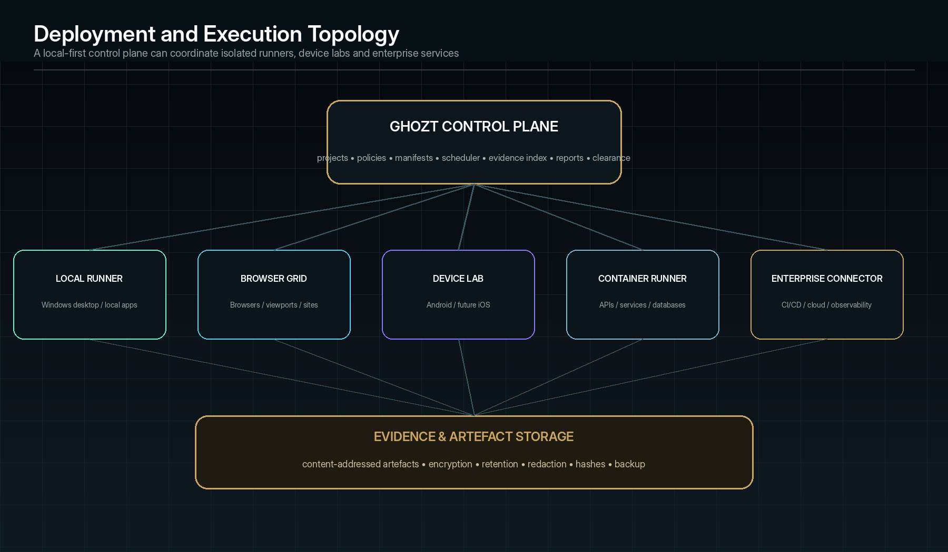
Reference topology: a local-first control plane can coordinate isolated execution without changing the evidence model.

Deployment profiles
Profile | Components | Use
Single workstation | Desktop shell, local database/index, local runner and encrypted evidence store. | Private Capital-Iz development and initial product validation.
Workstation + remote runners | Local/control server plus browser/device/container runners. | Parallel testing while keeping project control private.
Team server | Shared control/evidence services, roles, queues and local/remote runners. | Small engineering team and central review.
Enterprise private cloud/on-premises | High availability, SSO, policy, scalable workers, retention, integrations and audit. | Regulated or large-team operation.
Managed cloud (future) | Tenant-isolated control and execution, regional evidence, customer-managed keys where offered. | Public commercial service, only after privacy/security architecture is mature.

Scalability strategy
- Start with the smallest governed workflow that saves measurable developer time.
- Promote repeated workflows into reusable manifests, adapters, policies and guards.
- Partition runs by project/target/build and artefacts by content address.
- Scale execution horizontally through stateless or recoverable runners.
- Use queue priorities, quotas and resource classes for CPU, GPU, device and external-service cost.
- Stream events incrementally; do not load full logs or graph detail into the UI.
- Summarise old run detail while retaining immutable raw evidence under retention policy.
- Cache target discovery and invalidate by build/change evidence.
- Support concurrent teams without weakening per-project authority and data isolation.

Performance targets for Ghozt itself
Area | Initial design target
Desktop startup | Shell and prior target context visible quickly; background services validate progressively.
Event ingest | Sustain high-volume structured events without UI loss; back-pressure and disk queue.
State Lattice | Progressive rendering, clustering and virtualised detail for large graphs.
Evidence viewer | Stream large artefacts; generate thumbnails/previews asynchronously.
Search | Near-interactive metadata and code/error search across current project.
Run recovery | Restore control state after application/process restart without claiming lost actions complete.
Low-spec support | Operate core local workflows on the Capital-Iz backup PC through reduced concurrency/effects.

39 • THE TEST SYSTEM ALSO FAILS

Failure handling, recovery and degraded operation
Failure | Required response
Missing inputs | Block affected action, create visible task and preserve plan.
Permission denial | Deny, record actor/action/policy and offer legitimate request path.
Adapter unavailable | Mark capability unavailable, capture diagnostics and use approved fallback only.
Runner crash | Detect lease loss, seal completed events, mark uncertain in-flight action and recover/reset before retry.
Control-plane restart | Restore Sweep state from ledger; reconcile runners; never infer completion from queue absence.
Network partition | Queue safe events/actions, freeze misleading live indicators and reconcile when connection returns.
Evidence-store failure | Stop reportable high-risk execution if required evidence cannot be preserved; spool safely where permitted.
Storage pressure | Apply declared capture degradation and record omitted artefacts.
Clock/synchronisation loss | Preserve source order and uncertainty; do not fabricate exact sequence.
AI/model unavailable | Continue deterministic capabilities; mark intelligent analysis unavailable.
Low-confidence AI output | Route to human review and show missing evidence/assumptions.
Target crash | Capture crash and pre-failure evidence, contain side effects, attempt policy-controlled reset.
Rollback failure | Escalate, freeze further destructive work and record residual target state.
Report generation failure | Preserve source data, record export fault and retry without changing findings.

Retry principles
- Retry only when the action is known safe, idempotent or protected by a compensating/reset mechanism.
- Use bounded exponential back-off and dependency-specific policy.
- Record every retry as an event; do not overwrite the first failure.
- Distinguish infrastructure retry success from product fault recovery.
- A final success does not erase intermittent evidence; it may create a Phantom finding.
- Human review is required when uncertainty about side effects exceeds policy.
40 • THE TESTER TESTS ITSELF

Ghozt self-validation and quality certification
Ghozt cannot claim authority over other software if its own execution, evidence and reporting paths are unverified. The product therefore maintains a self-hosted Behaviour Manifest and regression programme.
Self-test domain | Required proof
Theme engine | All twelve palettes × Dark/Light/System, contrast, semantic invariance and effects off/on.
Permission engine | Allow/deny/approval/expiry across all action classes and roles.
Event ledger | No loss, duplicate identity, ordering/correlation behaviour and crash recovery.
Evidence integrity | Hash verification, derivative lineage, redaction, retention and access audit.
Run orchestration | State machine, pause/stop/cancel, retries, recovery and partial result.
Adapters | Contract, policy, error mapping, cancellation and evidence capture.
State Lattice | Versioning, provenance, graph diff, selection and large-graph performance.
Fault forensics | Fingerprint, replay, minimisation, envelope and counterfactual validity.
AI governance | Grounding, unsupported claims, permission bypass, tool misuse and low-confidence routing.
Reports | Claim-to-evidence links, DOCX/PDF layout, sensitive-content checks and digests.
Clearance | Mandatory gates, unknown risk, waivers, expiry, signatures and anti-gaming.
Upgrade/backup | Schema migration, rollback, evidence continuity, backup and restore.

Release gate for Ghozt
- No critical or high unwaived fault in evidence, permission, clearance or target-control functions.
- Mandatory regression suite passes on the supported Windows environment.
- Self-test evidence and report are generated by the release candidate itself and independently checked.
- Upgrade, rollback and restore are proven from the previous supported version.
- The published build, dependency and evidence digest are immutable and signed where configured.
- Known limitations and unsupported target capabilities are explicit.
41 • HOW THE SYSTEM IS USED

Exemplary embodiments and operating scenarios

Embodiment A — AI-assisted application from idea to publish
01 | Idea intake — A developer provides a product brief, intended users, features and constraints.
02 | Manifest proposal — Ghozt extracts features, workflows, expected outputs, permissions, risks and missing decisions.
03 | Implementation link — Source repository and running build are registered; source/runtime discoveries are reconciled.
04 | Autonomous Sweep — Ghozt exercises UI, endpoints, data and algorithms according to risk and change.
05 | Forensic finding — A multi-layer failure is reconstructed and supplied to the coding agent as a bounded Fix Brief.
06 | Verified repair — The repair is tested against the original reproducer, adjacent paths and generated guards.
07 | Clearance — The release policy evaluates evidence and produces a dossier or denial.
08 | Publish hand-off — CI/CD receives the machine decision and signed evidence digest.

Embodiment B — Hidden authentication fault
A UI login action appears to fail with a generic error. Ghozt correlates the click, loading state, POST request, service trace, token response, null claim, database/session state and rendered error. The fingerprint recurs through direct API testing. A counterfactual token with the claim present suppresses the fault; a token without it reproduces the fault. The Fix Brief limits changes to token parsing/session construction and requires UI, API, session, security and regression tests.

Embodiment C — Intermittent concurrency fault
A record is occasionally created twice. Ghozt preserves the original sequence, identifies overlapping requests and queue redelivery, repeats the workflow with controlled schedules, reduces it to two concurrent actions and one delayed acknowledgement, and records the reproduction envelope. Counterfactual idempotency keys or queue settings distinguish the causal mechanism. The resulting guard deliberately schedules the race window.

Embodiment D — Full endpoint sweep
Ghozt combines an API contract, source routes, observed client traffic and service discovery to enumerate endpoints. It classifies side effects and permissions, generates valid and invalid cases, sequences stateful calls, observes downstream data and queue effects, flags undocumented behaviour, and creates a release gate that requires contract, auth, error, idempotency and observability evidence.

Embodiment E — Algorithm validation
An optimisation algorithm lacks a complete exact oracle. Ghozt uses known examples, invariants, metamorphic relations, differential comparison and performance scaling. A fault appears only above a data-size boundary and under a specific precision mode. Ghozt records inputs, environment, output divergence, complexity change and a minimised case, then generates a durable property test.

Embodiment F — Performance regression with causal context
A page becomes slow after a build. Instead of reporting only a score, Ghozt aligns user interaction, render timing, network waterfall, service spans, database query, CPU profile and changed source dependencies. A counterfactual cache configuration and isolated query version demonstrate the supported bottleneck, while the report explains both user impact and technical mechanism.

Embodiment G — Controlled production observation
A production-only Phantom cannot be reproduced in staging. Under explicit authority, Ghozt activates read-only, privacy-minimised anomaly capture and correlates a bounded pre/post window. It does not inject destructive conditions or disclose restricted evidence to unauthorised agents. The captured state is replayed in an isolated environment for deeper intervention.

Embodiment H — Multi-application Capital-Iz quality command
Ghozt maintains separate targets, policies and evidence for several Capital-Iz applications. Shared adapters and regression patterns are reused, while each product retains distinct manifests and clearance gates. Cross-product dependencies appear in the State Lattice and receive change-impact re-testing when a shared service or library changes.
42 • IP DISCLOSURE MAP

Candidate inventive concept families
PATENTABILITY CAUTION
The following are candidate concept families for professional prior-art review and claim drafting. Inclusion here does not establish novelty, inventive step, eligibility or freedom to operate.

Family | Candidate inventive substance | Technical effect
A. Behavioural truth triangulation | Generating a versioned Behaviour Manifest by reconciling declared intent, implementation extraction and runtime observation while preserving provenance, conflicts and confidence. | Reduces false or stale oracles and exposes undeclared or missing behaviour.
B. Evidence-bound State Lattice | A graph whose nodes/edges jointly represent expected, discovered, observed, inferred and decided software state with temporal/build scope and evidence bindings. | Unifies model-based testing, coverage, causal tracing and reporting.
C. Governed risk-and-novelty exploration | Selecting permissible next actions from a state frontier using risk, change, novelty, coverage gain, dependency, history, uncertainty, cost and side-effect constraints. | Improves valuable coverage under finite budgets without surrendering policy.
D. Multi-source forensic event alignment | Normalising UI, API, service, data, algorithm, environment and agent events into a supported partial order with ordering uncertainty. | Reconstructs cross-layer fault sequences even when clocks/sources differ.
E. Composite fault fingerprint | Normalising semantic diff, sequence, state delta, lattice context, dependency trace and environment into exact and similarity identities. | Deduplicates equivalent failures and preserves variants.
F. Reproduction envelope | Representing the conditions, success rate, uncertainty, ranges and suppressors of an intermittent fault rather than a binary reproduced/not-reproduced label. | Converts flaky behaviour into testable conditional knowledge.
G. Counterfactual forensic intervention | Creating controlled branches that change suspected factors while preserving the material reproducer and ranking cause by supporting/contradicting outcomes. | Strengthens root-cause claims beyond correlation.
H. Evidence-constrained repair brief | Generating an allowed/forbidden change scope and mandatory verification set directly from a supported finding and causal graph. | Bounds human/AI repair and links change to proof.
I. Automatic regression memory | Converting verified feature contracts and repaired fingerprints into versioned guards tied to graph regions, change impact and evidence freshness. | Preserves learned quality across releases.
J. Unknown-aware release clearance | Evaluating mandatory gates, weighted verified scope, failed/blocked/waived/unverified risk, evidence freshness and approvals into a signed decision. | Prevents high scores from hiding critical unknowns.
K. Dual-output provenance reporting | Generating human narrative and machine results from one evidence graph with claim-to-artefact references and matching digests. | Maintains traceability across technical and executive outputs.
L. Supervised agent execution loop | Separating agent observation/recommendation from policy-gated service execution and evidence verification for testing and repair. | Prevents hidden AI authority and fabricated completion.

Potential combinations with strongest product identity
- A + B + C: behaviour-manifest triangulation feeding autonomous evidence-bound exploration.
- D + E + F + G: full counterfactual forensic reconstruction of intermittent cross-layer faults.
- G + H + I: causal finding converted into bounded repair and durable regression memory.
- B + J + K: evidence-bound state coverage converted into unknown-aware clearance and professional reporting.
- C + L: agent-guided exploration whose actions remain independently policy-gated and verified.

Design-around resistance considerations for counsel
- Draft claims around functional relationships and data flow, not only named modules or UI labels.
- Cover centralised and distributed implementations, local and cloud deployments, and human or AI planners.
- Cover exact graph stores and logically equivalent representations.
- Cover deterministic and probabilistic exploration strategies.
- Cover full counterfactual intervention and narrower one-factor reproduction tests.
- Cover evidence stored internally or through referenced external systems.
- Cover code repair by human, agent or external coding system receiving the bounded brief.
- Cover clearance outputs used directly by CI/CD, release manager or certificate.
43 • FOR PATENT COUNSEL DEVELOPMENT

Illustrative claim-concept skeleton
The following language is intentionally a technical skeleton rather than final legal claims. Patent counsel should rewrite it after inventor interviews, prior-art review and jurisdiction analysis.

Independent system concept
SYSTEM CONCEPT
A software examination system comprising: a manifest engine configured to derive and version expected behaviour from at least two of declared intent, implementation structure and runtime observation; a state model configured to represent expected and observed software states and transitions with evidence bindings; an exploration controller configured to select and execute permissioned actions against a target; an event and evidence subsystem configured to preserve time-correlated actions, state changes and artefacts; a forensic subsystem configured to identify a deviation, reproduce a corresponding failure and evaluate at least one controlled counterfactual condition; and a certification subsystem configured to determine a release state from verified, failed and unverified weighted scope.

Independent method concept
METHOD CONCEPT
A computer-implemented method comprising: obtaining intent data and implementation or runtime data for a software target; generating a versioned behavioural representation including expected states, transitions and verification criteria; autonomously selecting a permissible path through reachable target states; capturing a time-correlated sequence of actions, actual states and evidence; detecting an expected-versus-actual deviation; generating a reproducer; varying a candidate causal factor while preserving remaining material conditions; updating a causal confidence according to the result; generating a bounded repair or regression specification; and issuing a policy-based release determination that preserves unverified scope.

Independent storage-medium concept
COMPUTER-READABLE MEDIUM CONCEPT
A non-transitory computer-readable medium storing instructions that, when executed, cause one or more processors to perform the method or operate the system described above.

Illustrative dependent concept set
No. | Dependent concept
1 | wherein provenance identifies whether a behaviour element was declared, extracted, observed, inferred or human-decided;
2 | wherein the state representation is a graph comprising feature, action, endpoint, data, algorithm, fault and evidence nodes;
3 | wherein action selection is based on at least risk, change impact, novelty, expected coverage gain and execution cost;
4 | wherein the permission gate separately controls observation, state-changing, destructive, sensitive-data and code-modification actions;
5 | wherein events from different clock sources are combined into a partial order with ordering confidence;
6 | wherein the fault fingerprint comprises a semantic output difference, action-sequence sketch and state-delta sketch;
7 | wherein similar fingerprints are clustered as related candidates without automatically merging findings;
8 | wherein the reproducer is minimised by removing actions, inputs, state or environment conditions while preserving a fault fingerprint;
9 | wherein a reproduction envelope stores required, sufficient, suppressing or correlated conditions and a reproduction rate;
10 | wherein the counterfactual condition changes an input, state, sequence, dependency, timing, environment or implementation factor;
11 | wherein supporting and contradicting counterfactual outcomes update a ranked causal hypothesis;
12 | wherein the repair specification defines allowed and forbidden source-code scope and mandatory verification tests;
13 | wherein an AI agent proposes a change but a separate permissioned service executes the change;
14 | wherein successful verification generates a regression guard bound to the affected behavioural graph region;
15 | wherein evidence freshness is invalidated by change-impact relationships;
16 | wherein clearance is denied when a mandatory gate fails irrespective of aggregate coverage;
17 | wherein blocked and excluded scope are displayed separately from passed scope;
18 | wherein a waiver includes scope, approver, compensating control and expiry;
19 | wherein human-readable and machine-readable reports share an evidence digest;
20 | wherein evidence derivatives preserve a relationship to an original artefact and transformation history;
21 | wherein capture fidelity changes in response to anomaly, performance, sensitivity or storage conditions and the change is itself recorded;
22 | wherein the target is a web, desktop, mobile, service, algorithm, model, data pipeline or deployment system;
23 | wherein the system tests an algorithm using at least one of property, metamorphic, differential, mutation or fuzz testing;
24 | wherein the system tests a probabilistic model using versioned data, seed, slice, drift or calibration evidence;
25 | wherein the release determination is supplied to a deployment pipeline to allow or block promotion.

Potential separate filings / continuations
- Core autonomous evidence-bound testing platform.
- Counterfactual software fault-forensics and reproduction-envelope method.
- Evidence-constrained AI repair and regression generation.
- Unknown-aware quality-clearance and certification system.
- Algorithm/model forensic validation using the same state/evidence framework.
- Graphical State Lattice interaction may support design-protection review separately from utility concepts.
44 • BUILD ORDER

Implementation programme and technical gates
A patent-level blueprint should describe the full destination, but implementation should still begin with the smallest governed workflow that saves measurable time and proves the evidence model.
Phase | Capability | Gate
Phase 0 — Canonical contracts | Lock IDs, event schema, target/build/authority, manifests, evidence and finding lifecycle. | Schemas pass round-trip/versioning tests; no hidden state.
Phase 1 — Local control plane | Windows desktop shell, project/target registry, local store, policy basics and run state machine. | Target context, authority and audit visible.
Phase 2 — Evidence substrate | Append-only events, artefact store, hashes, screenshots/logs and chain of custody. | A manual test can produce a complete evidence bundle.
Phase 3 — Web/UI + API adapters | Discover and execute controlled browser/UI and HTTP paths. | Full cross-layer sequence reproduced for one reference app.
Phase 4 — Behaviour Manifest | Ingest requirements/source/runtime and manage conflicts/provenance. | Expected and observed states remain distinct.
Phase 5 — State Lattice | Graph model, coverage, navigation, change impact and path history. | Large graph remains usable and evidence-linked.
Phase 6 — Autonomous Sweep | Frontier, risk/novelty scoring, budgets, reset and permission gates. | Unscripted safe path discovery adds verified coverage.
Phase 7 — Forensic replay | Timeline, fingerprint, repeat, minimisation and Phantom workflow. | One intermittent fault receives a measurable envelope.
Phase 8 — Counterfactual Lab | Intervention controls, hypothesis object and evidence ranking. | A cause candidate is supported and contradicted experimentally.
Phase 9 — Fix/agent integration | Fix Brief, branch-bounded code service and required re-test. | Agent cannot exceed change scope; success requires evidence.
Phase 10 — Regression memory | Guard generation, change impact, freshness, flake and mutation controls. | Repaired fault fails before fix and passes after fix.
Phase 11 — Algorithms/data | Harnesses, property/metamorphic/differential and data validation. | Non-UI algorithm receives complete forensic report.
Phase 12 — Reports/clearance | DOCX/PDF/JSON output, gate engine, waiver and certificate. | Same evidence supports human report and machine release decision.
Phase 13 — Scale and enterprise | Remote runners, roles, secrets, retention, integrations and high availability. | Isolation, recovery and audit proven under concurrency.
Phase 14 — Self-hosting | Ghozt examines its own release candidate. | Self-clearance independently verified before release.

Reference implementation priorities
- Windows 11 Pro desktop runtime and VS Code-compatible development workflow.
- Local-first operation with no cloud dependency for core capability.
- Browser/web application and API targets first because they expose the complete UI→endpoint→service→data evidence chain.
- A reference Capital-Iz app used as the self-hosted target.
- Deterministic tools and evidence substrate before advanced AI autonomy.
- Demo/test environments before any production execution capability.
- Performance calibrated to the current main and backup Capital-Iz PCs.
45 • HONEST BOUNDARIES

Known limitations, unresolved decisions and research register
Area | Current position / unresolved work
Exhaustiveness | Complete enumeration is impossible for many unbounded state spaces; Ghozt must report scope, budget and unknown risk rather than promise total proof.
Causality | Counterfactual evidence may still be limited by unsafe interventions, hidden variables or non-reproducible environments.
Oracle problem | Not every output has a reliable expected answer; invariants, metamorphic and human approval remain necessary.
Instrumentation effect | Capture and fault injection can alter timing/performance; overhead must be measured and disclosed.
Production testing | Should remain exceptional, minimal and explicitly authorised; isolated replay is preferred.
AI reliability | Agents can hallucinate, overgeneralise or misuse tools; deterministic evidence and service gates remain authoritative.
Platform adapters | Capabilities vary by framework, OS, device and access level; unsupported surfaces stay visible.
Evidence volume | High-fidelity capture is expensive; adaptive capture and retention policies are required.
Privacy and legal | Target-data processing obligations vary by jurisdiction and client; specialist legal review is required before public/enterprise use.
Patentability | No novelty or freedom-to-operate conclusion exists until professional searches and claim analysis are completed.
Commercial packaging | Private, team, enterprise and managed deployment remain product decisions, not technical assumptions.

Research directions
- Learned exploration policies that optimise uncertainty reduction without bypassing deterministic constraints.
- Causal discovery across event graphs combined with active safe interventions.
- Program synthesis for minimal reproducer generation.
- Cross-application regression patterns and reusable behavioural abstractions.
- Privacy-preserving evidence analysis and local model execution.
- Hardware/device digital twins for embedded and mobile state exploration.
- Formal-method integration for critical invariants and model checking.
- Automated oracle confidence calibration and dispute resolution.
- Federated quality intelligence that shares patterns without exposing proprietary evidence.

Source inheritance and Ghozt-specific expansion
Source authority | Inherited doctrine | Ghozt-specific expansion
Capital-Iz Dev Tester Platform Blueprint | Control, Execution and Intelligence layers; evidence-backed testing; unit, integration, UI, workflow, security, performance and deployment smoke validation. | Autonomous state exploration, forensic replay, counterfactual causality, algorithm laboratories, evidence dossiers and release clearance.
Universal Blueprint Development Doctrine | Structure → Validation → Execution → State → Event → Audit; rejection of hidden logic and unverifiable execution. | Each Ghozt workflow, agent and test adapter receives explicit contracts, permissions, failure states, verification and audit output.
Capital-Iz AI Architecture Blueprint | Supervised intelligence; bounded roles; approval before high-risk execution; evidence recording. | Specialist test agents, causal-analysis agents, fix-brief agents and report agents governed through policy gates.
Capital-Iz Universal Design System | Clarity over decoration; high contrast; restrained premium accents; action-first, reusable and state-visible UI. | Restricted forensic-tech visual language, state lattice, black-box stream and twelve Ghozt palettes.
CommandDeck implementation reference | Semantic theme tokens, runtime palette switching, dark/light derivation, controlled glass/gradient/glow and responsive operational layout. | A new Ghozt token namespace, twelve product-specific palettes, tighter forensic geometry and evidence-first workspaces rather than copied CommandDeck screens.

APPENDIX

Appendix A — Example forensic finding record
finding_id: FLT-00217
title: Session refresh produces HTTP 500 and retained loading state
target/build: TGT-17 / BLD-219
environment: TEST-WIN11-01
severity: HIGH
status: CAUSE_SUPPORTED
expected:
http: 200 SessionResponse
ui: authenticated + dashboard_loaded
actual:
http: 500
ui: loading state retained; generic error shown
fingerprint: FP-88A19
reproducer: RPR-0042 (4/4 valid attempts)
minimal_sequence:
1. authenticate with valid credentials
2. advance session clock to refresh window
3. trigger protected navigation
4. refresh token lacking identity claim is parsed
cause_hypothesis:
null identity claim bypasses session construction
confidence: 0.93
counterfactuals:
CFX-31 claim restored -> no fault
CFX-32 direct API same null claim -> same fingerprint
evidence: [EVD-84..EVD-91]
fix_brief: FXB-0019
required_guards: [unit parser, API refresh, UI session, security denial]
release_effect: CLEARANCE_DENIED until verified

APPENDIX

Appendix B — Example clearance digest
clearance_id: CLR-00071
target/build: TGT-17 / BLD-223
policy: Release-Standard@v4
decision: CONDITIONALLY_CLEARED
verified_weighted_coverage: 0.94
unknown_risk: 0.03
mandatory_gates:
unit: PASS
integration: PASS
ui_core: PASS
security_auth: PASS
accessibility_core: PASS
performance: PASS_WITH_CONDITION
open_findings:
MEDIUM: 1 (waived, expiry 2026-09-15)
waiver: WVR-0012
evidence_digest: sha256:…
report: RPT-0099
approvers: [ENG-LEAD-02, RELEASE-01]
valid_until: 2026-09-15T23:59:59+02:00

APPENDIX

Appendix C — Patent-preparation evidence checklist
- Preserve dated versions of this disclosure and future architectural revisions.
- Record inventor contributions by concept family, not merely job title.
- Keep private prototypes, diagrams, run evidence and experimental results supporting technical effects.
- Document failed approaches and why the chosen architecture improves them.
- Avoid public disclosure before professional filing strategy is decided.
- Commission a prior-art search across testing, model-based exploration, observability, causal debugging, evidence systems, AI repair and release certification.
- Map candidate claims to concrete embodiments and supporting implementation detail.
- Separate brand/trademark protection for Ghozt from utility-patent concepts and possible design protection.
- Review open-source and third-party licences for adapters and incorporated tools.
- Engage qualified patent counsel for South African and intended international filing strategy.
APPENDIX

Appendix D — System acceptance criteria
- A target/build cannot be tested without visible identity and authority.
- Every workflow has inputs, outputs, owner, permission, risk, failure and verification.
- Every material execution creates an event and before/after state where applicable.
- Every finding exposes expected, actual, sequence, evidence and reproducibility.
- Every causal statement shows supporting and contradicting evidence.
- Every code change is bounded by an approved Fix Brief and service permissions.
- Every repaired fault creates or updates a Regression Guard.
- Every report claim links to source evidence or approved manifest intent.
- Every clearance decision exposes blocked, waived and unverified scope.
- Every adapter and agent is contract-, permission-, failure- and audit-tested.
- Every AI output distinguishes draft/recommendation from executed/verified fact.
- Every partial, denied, failed or degraded operation remains visible and recoverable.
- The system can operate without decorative theme effects and without AI for deterministic core functions.
- Ghozt’s own release is examined by the same system and independently reviewed.

Ghozt
END OF CONTROLLED BLUEPRINT
This document forms part of the Capital-Iz Ghozt canonical product specification. Superseding revisions must preserve the naming lock, evidence doctrine, authority boundaries and traceability requirements defined herein.
CAPITAL-IZ • BUILD TRUTH. PRESERVE EVIDENCE. EARN CLEARANCE.

